Issue#1- Users > Add / Update screen > Permissions > Read / Manage do not save for Web Break / Rule / Alerts and Phone also do not save in User Add/Update cases

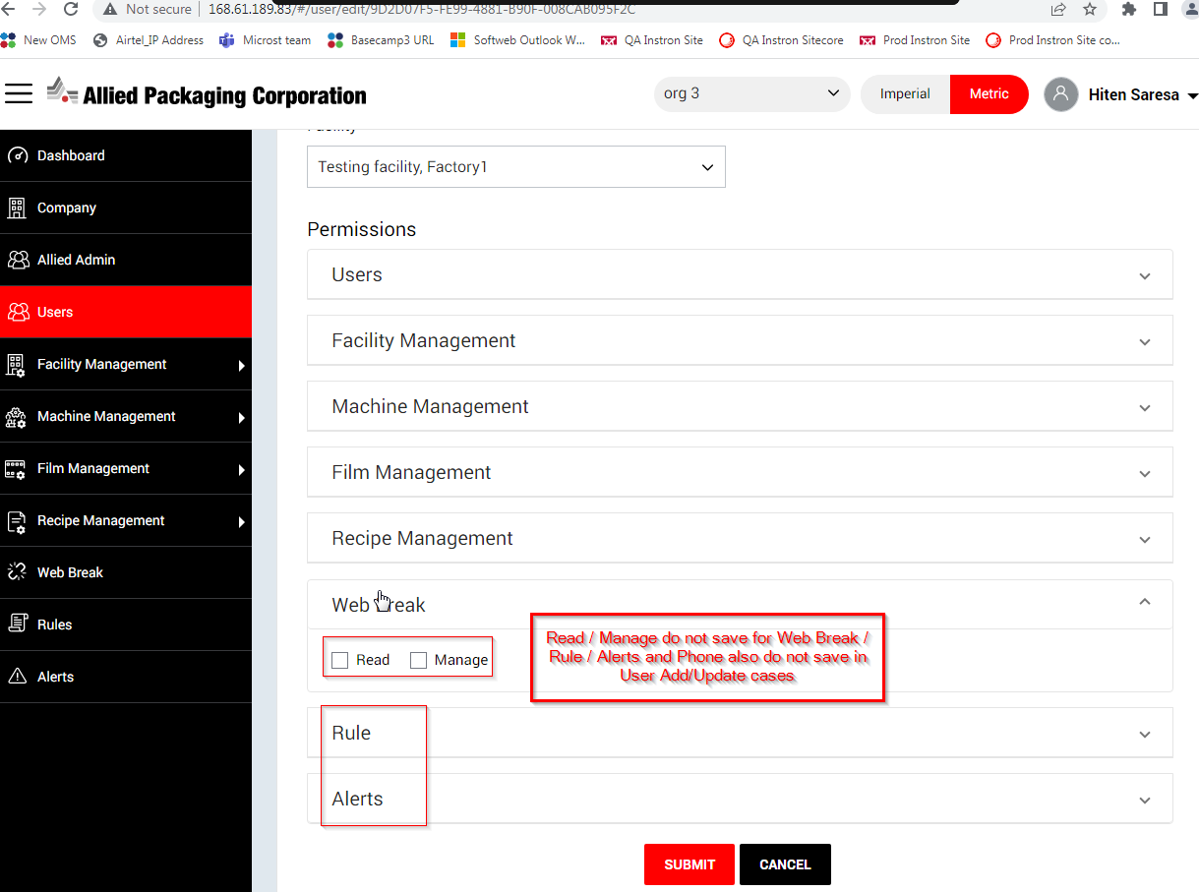

For Location* field , Validation should be Location instead of Facility Name in across pages

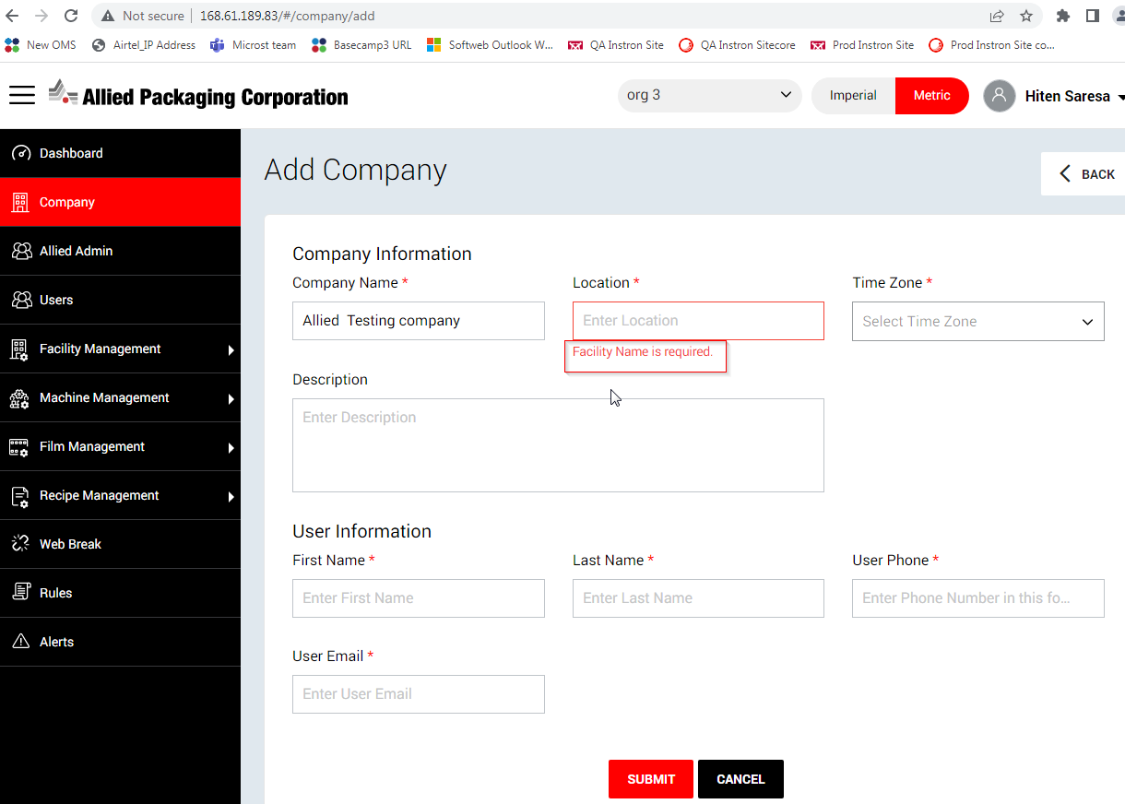

In Add/Update Company page, entered email address seeing overlapped with User Email* field

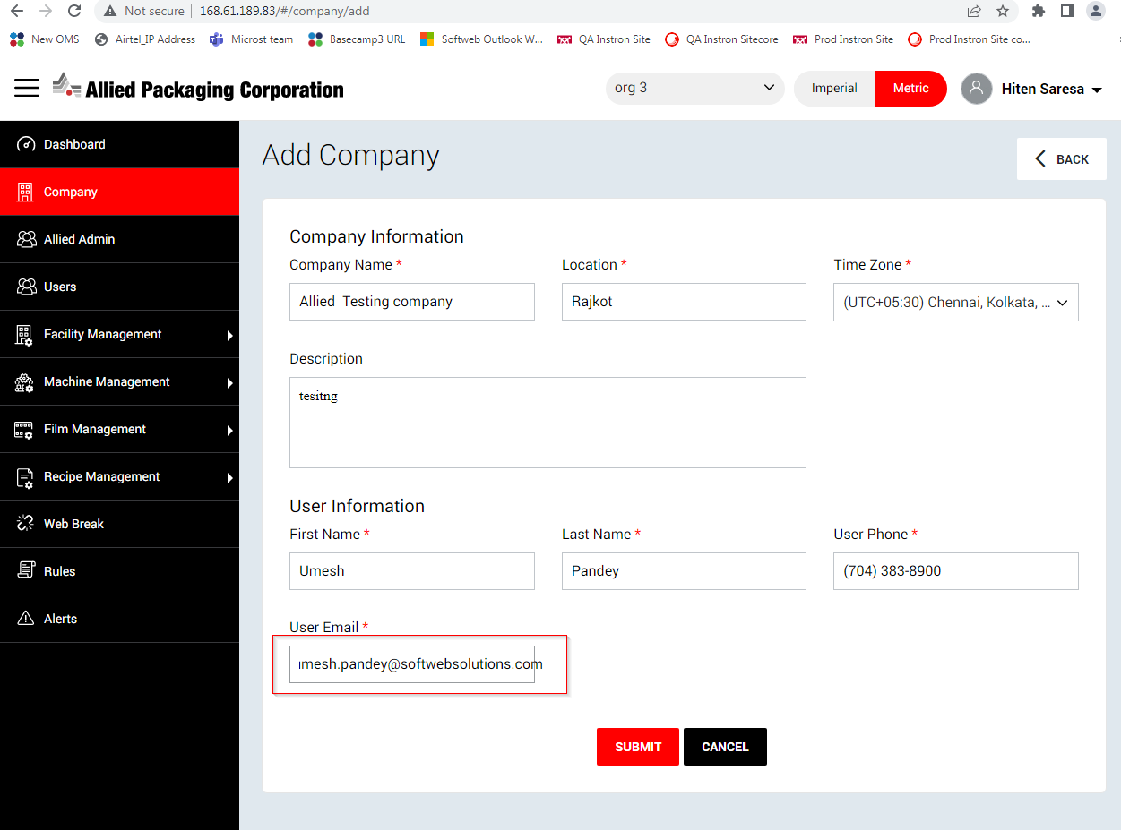

After creating new company , successful message do not comes on UI

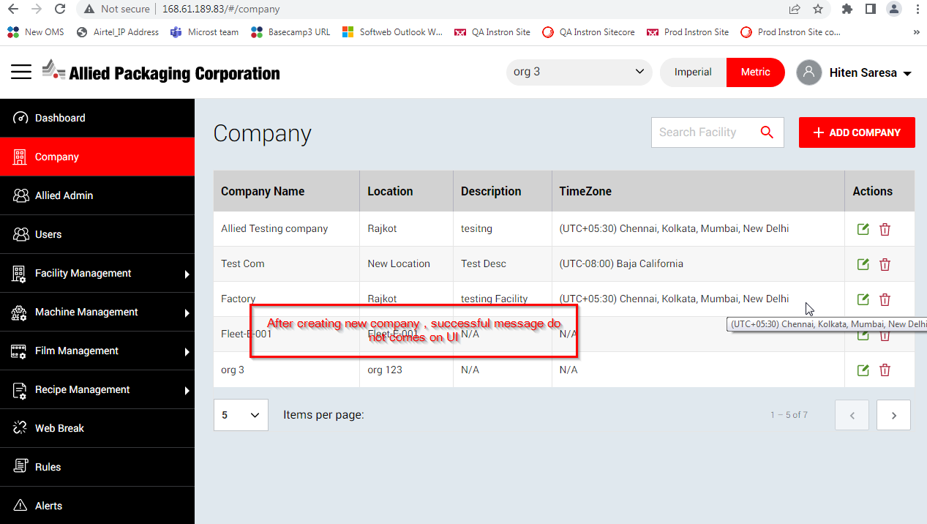

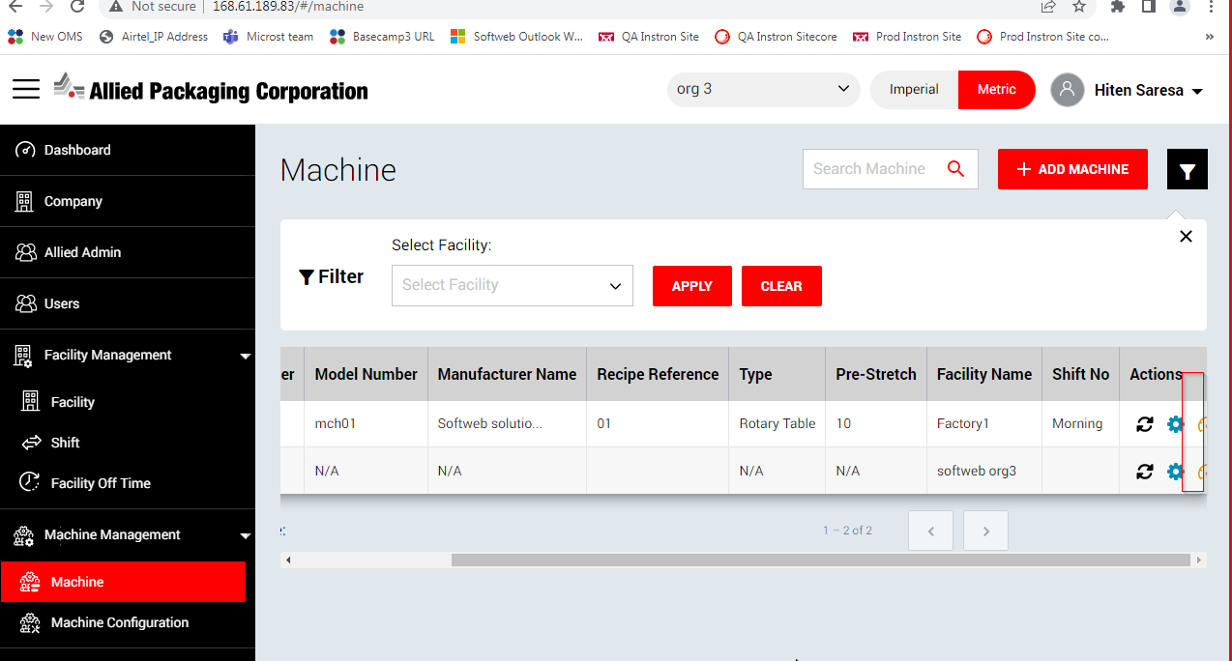

Data do not retrieve on Edit Recipe page

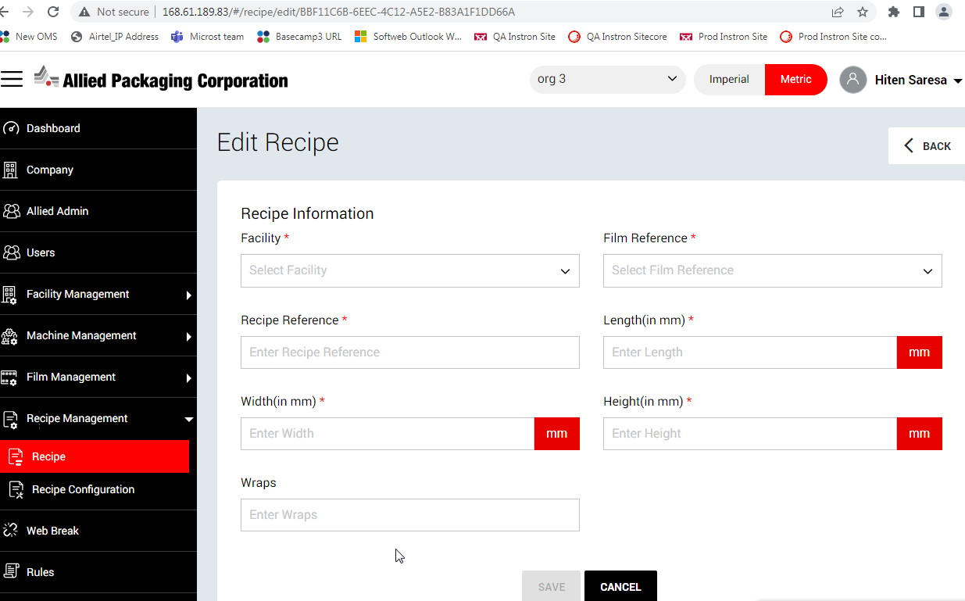

After creating a new Allied Admin details , Company* and Facilities* field getting reset from Edit page

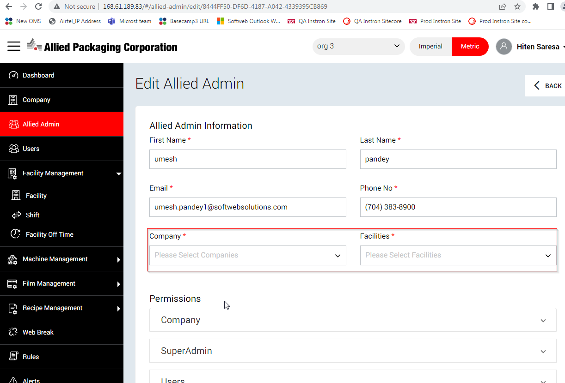

Validation do not comes for email address when enter in invalid format

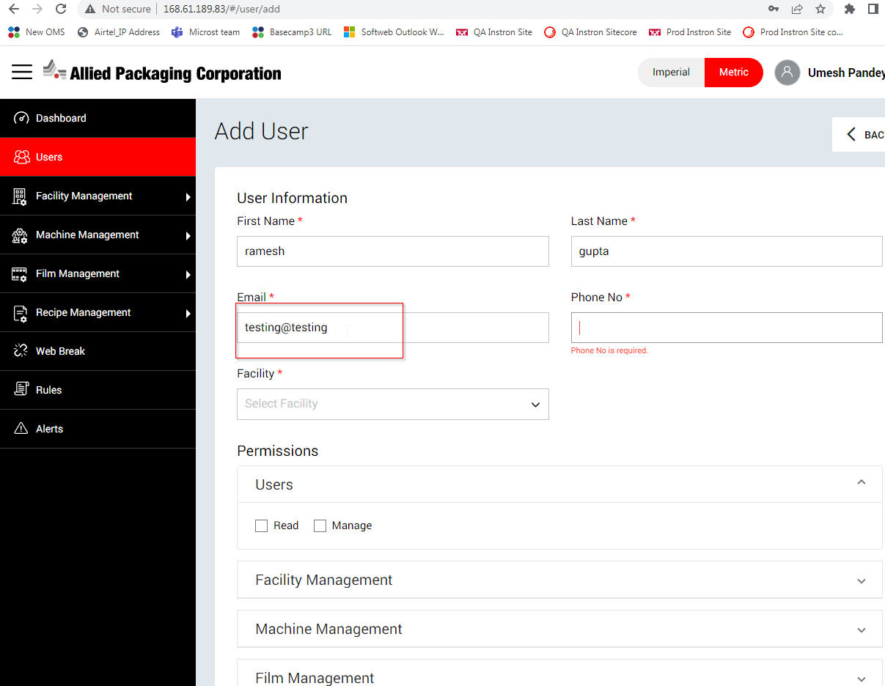

Under company drop down , list do not display in ascending order

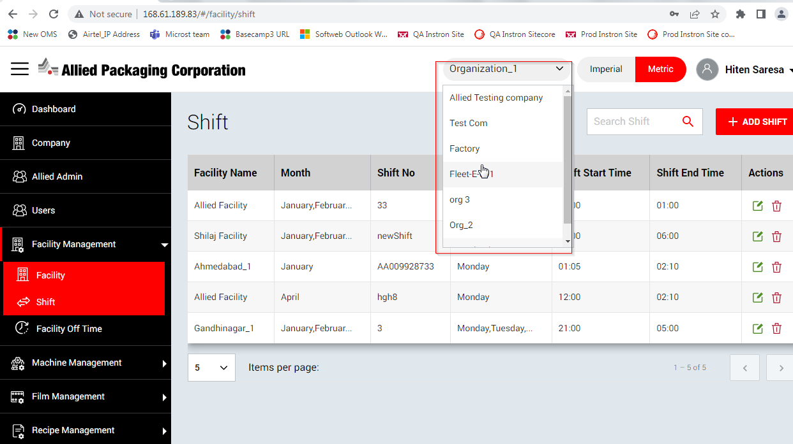

When user login with own credentials and goto > Dashboard , Facilities and Machine count displaying wrong.

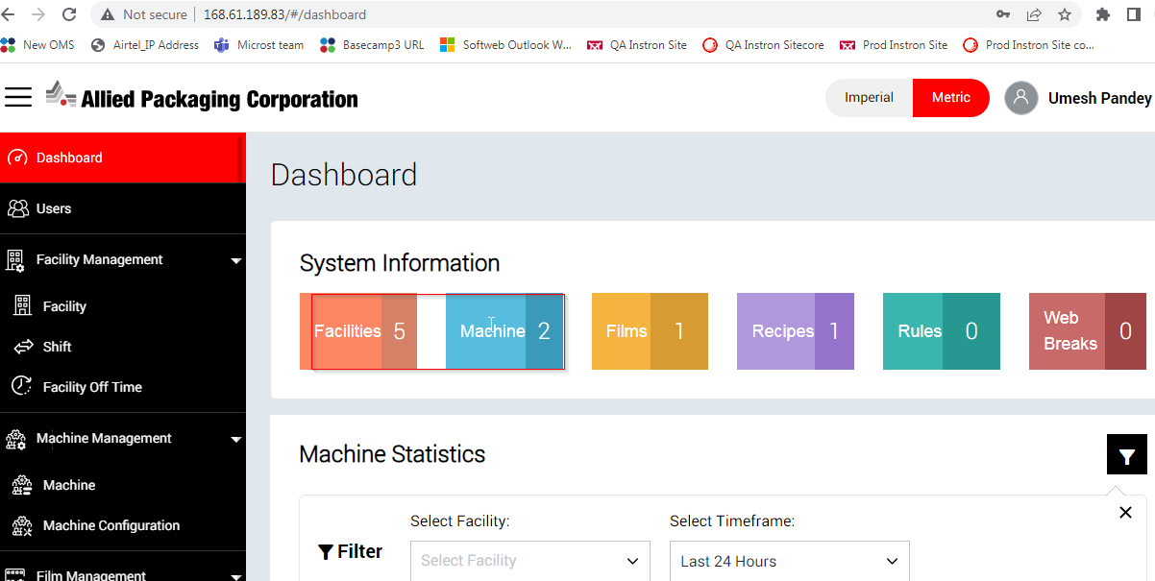

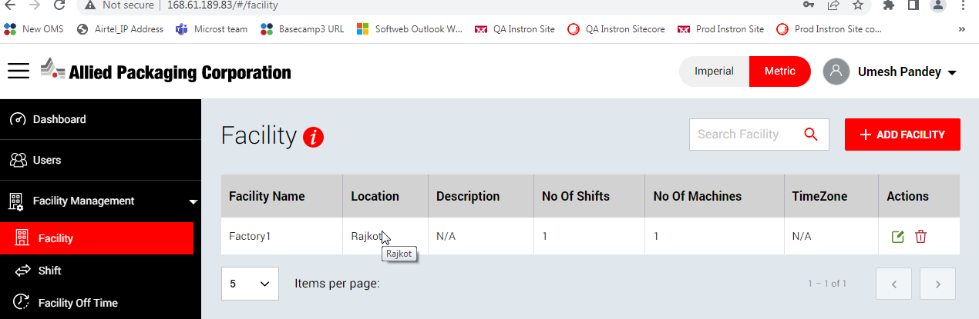

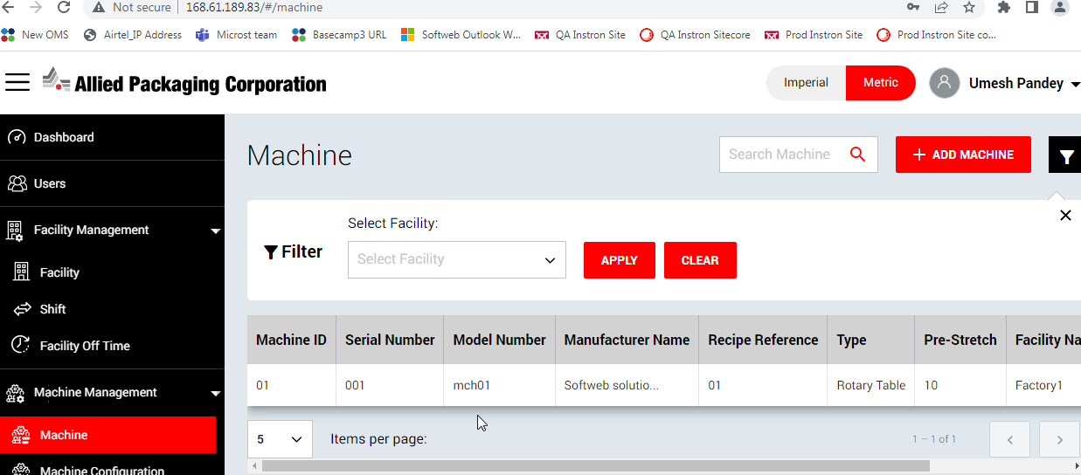

Should display “view” option to user if super admin / allied admin given view permission only for particular that section and user going to check by logged in his credentials

Need to be remove unnecessary details which is not applicable for User in across application

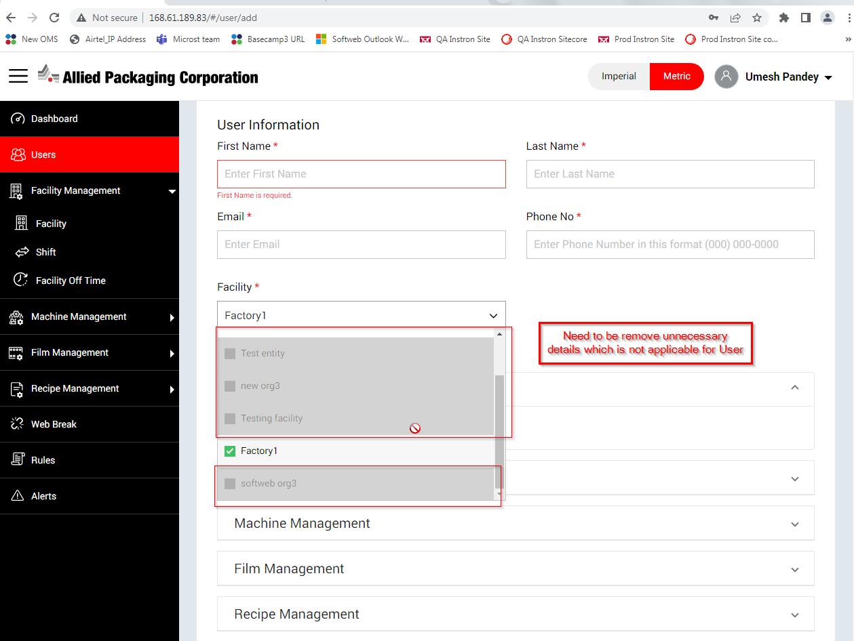

Pagination option also scrolling in across the pages when horizontal scrolling enable and user scrolling that

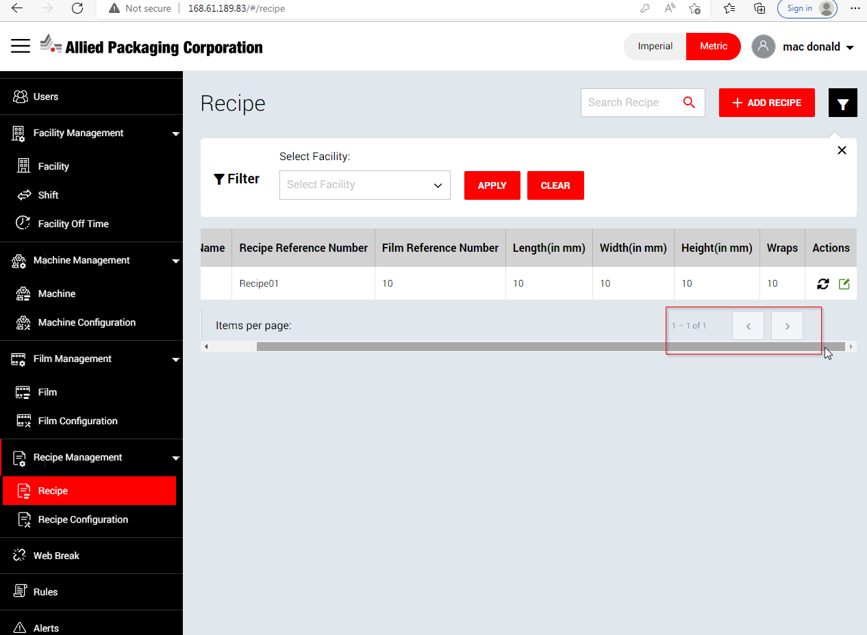

Permission changes do not applied on Save button

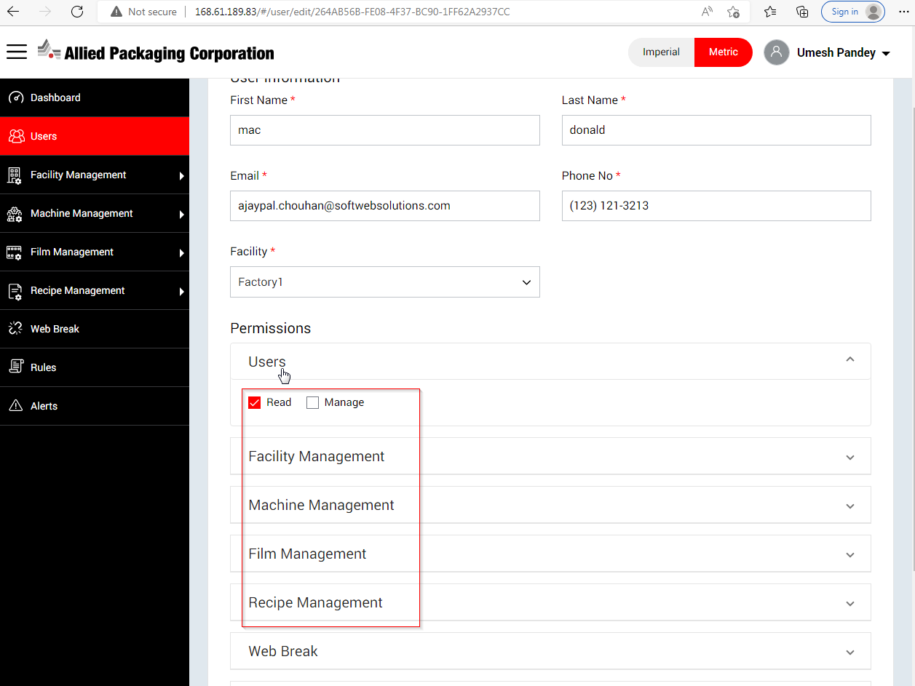

For Facility Off Time page , not seeing any Actions (View / Edit / Send) even though user have Manage or View permission.

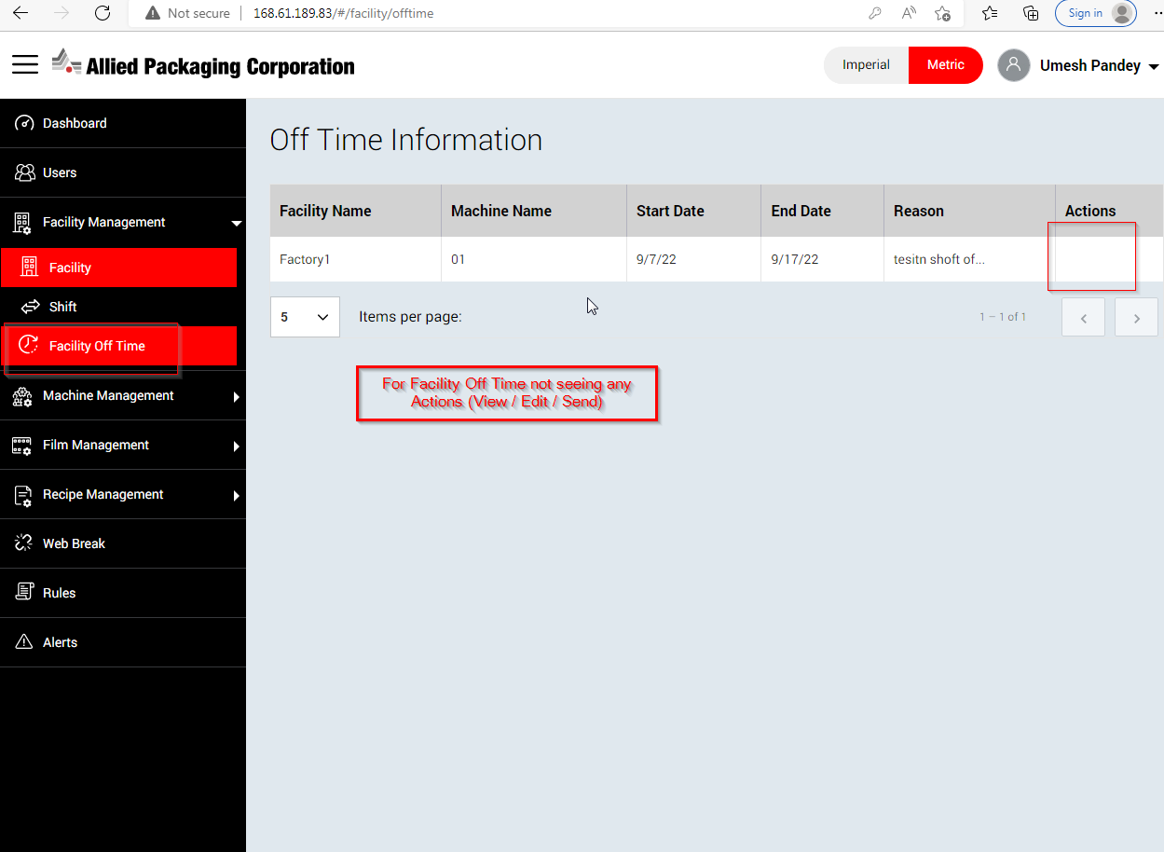

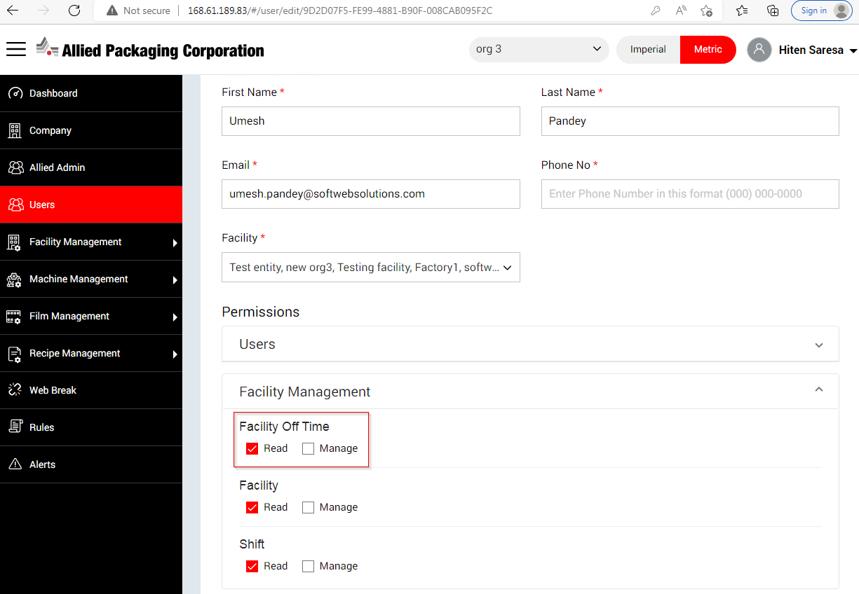

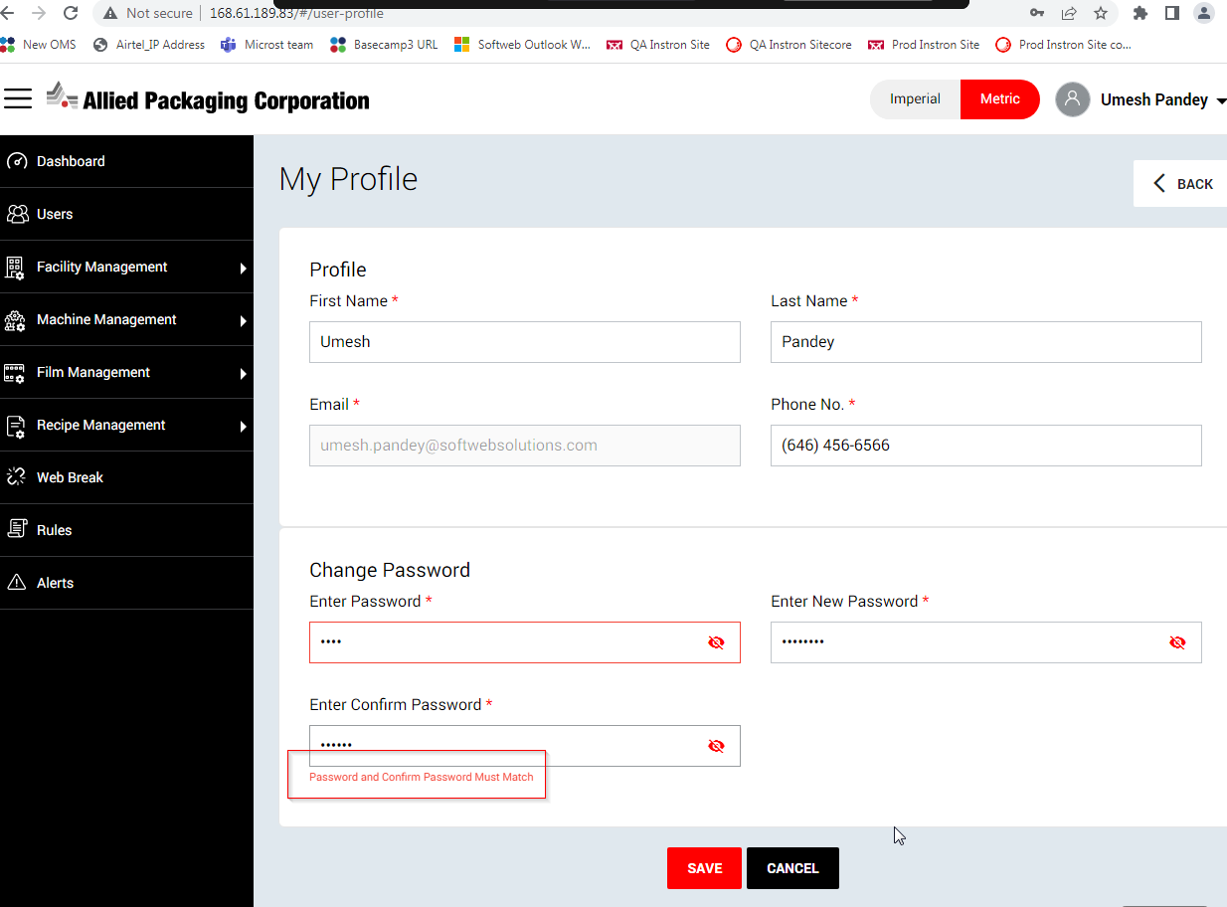

After updating user profile , “undefined’ keyword showing in drop down at top right corner

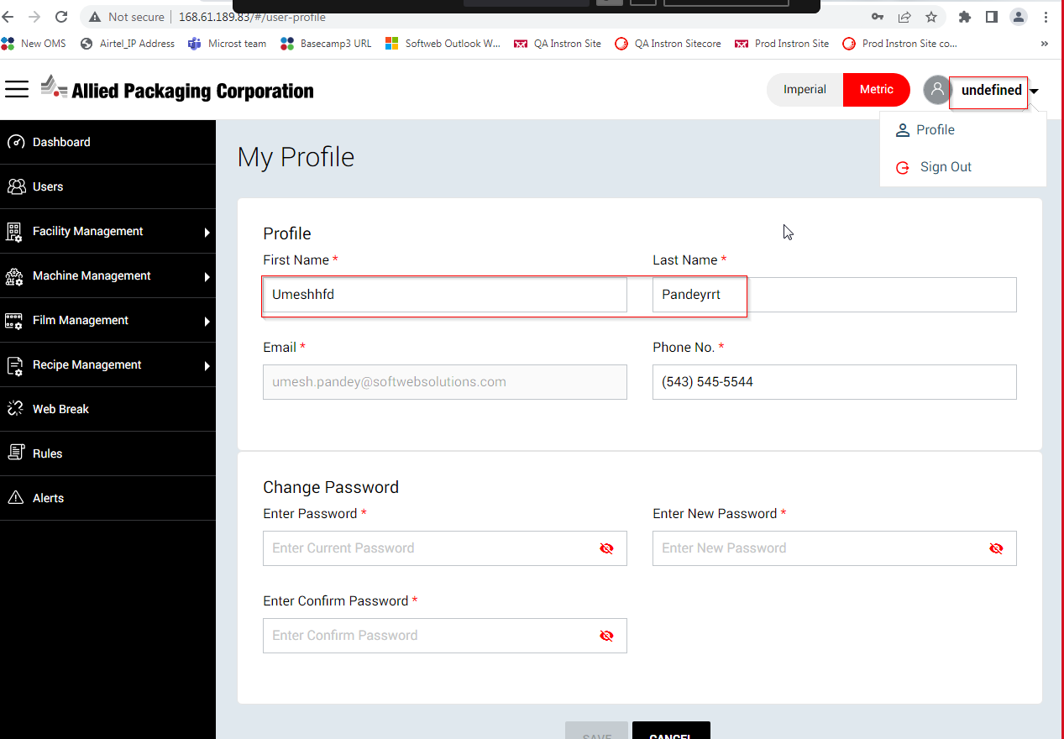

Web Break filter count displaying wrong in grid table based one selected Facility and Machine

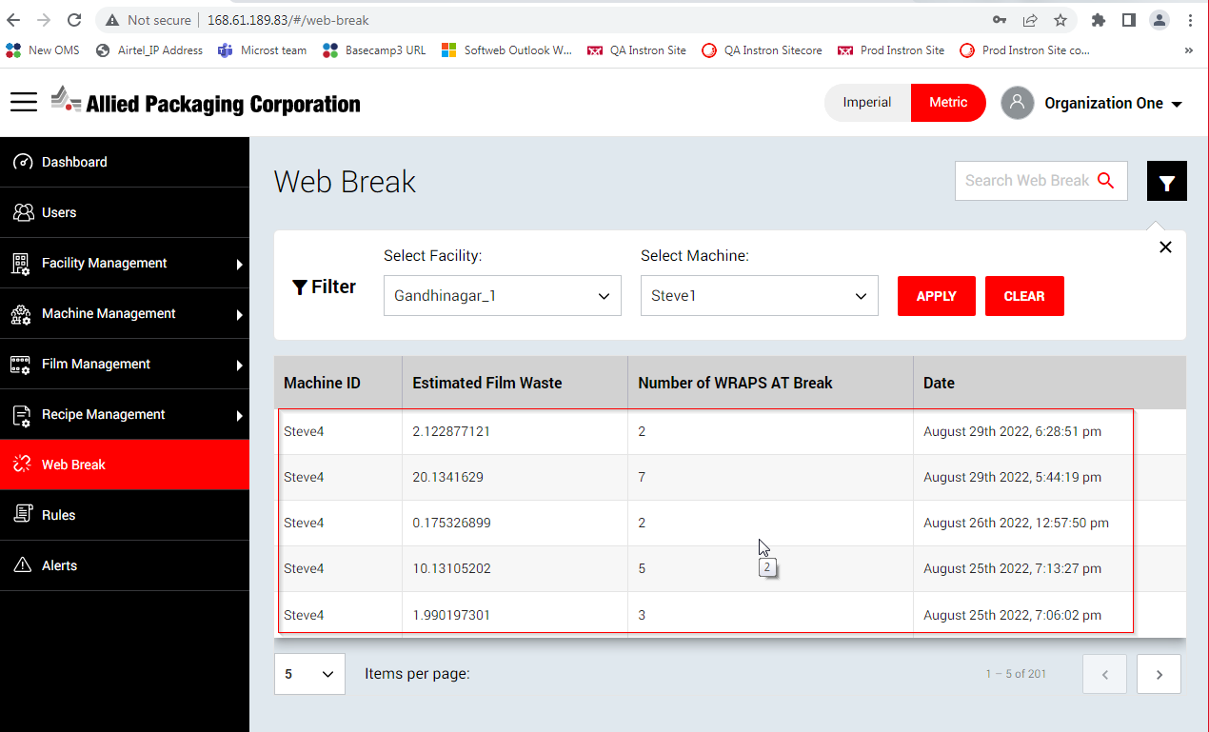

While adding new Facility then above alert throwing but new facility Add successfully

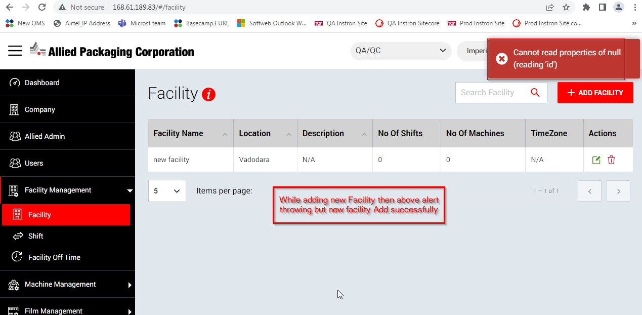

Created new facility getting removed from Facility grid table and displaying in Company module as well as Company drop down when user just create new facility and update it

**Steps**:

1. Goto > Facility and create it
2. Now click Edit button and modify the facility details
3. Observe the behaviour
4. Goto > Company module and Company drop down and see the behaviour

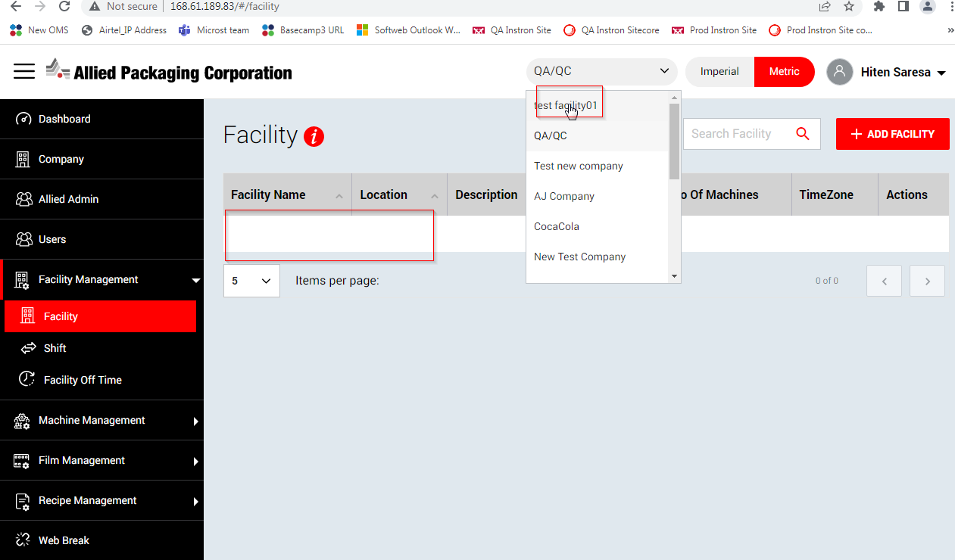

From Shirft module , when click Delete button the “undefined” text displaying me delete popup

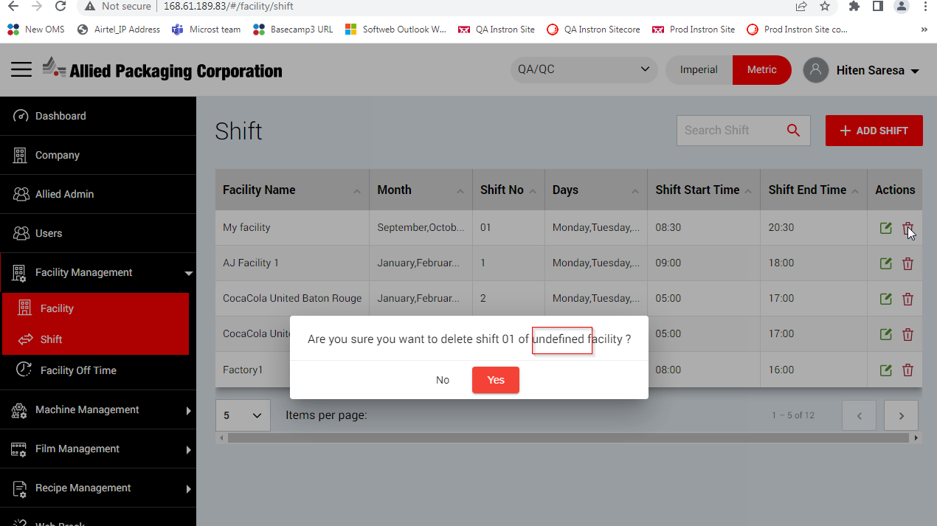

From Shift module , when search with any keyword then loader displaying and loader unable to stop

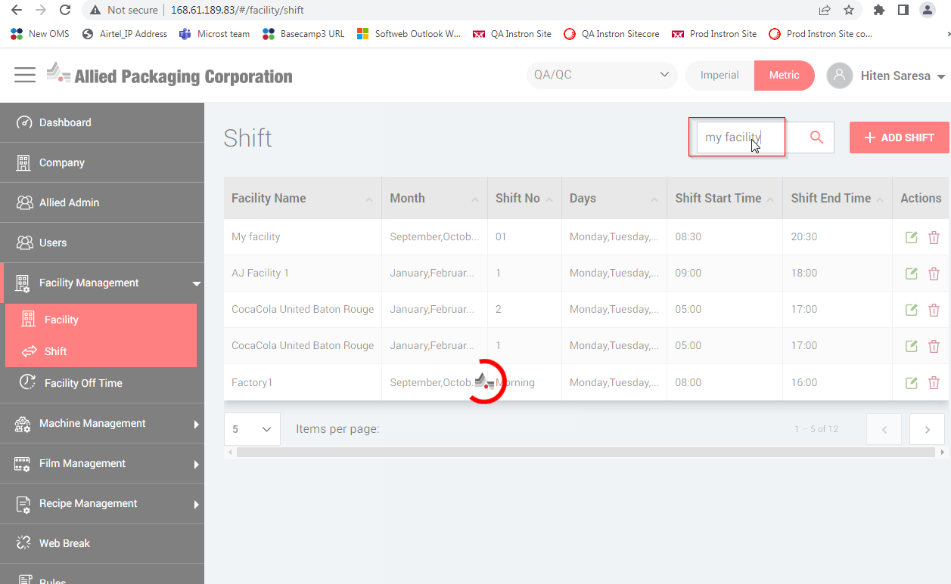

From Recipe module , when search with any keyword then loader displaying and loader unable to stop

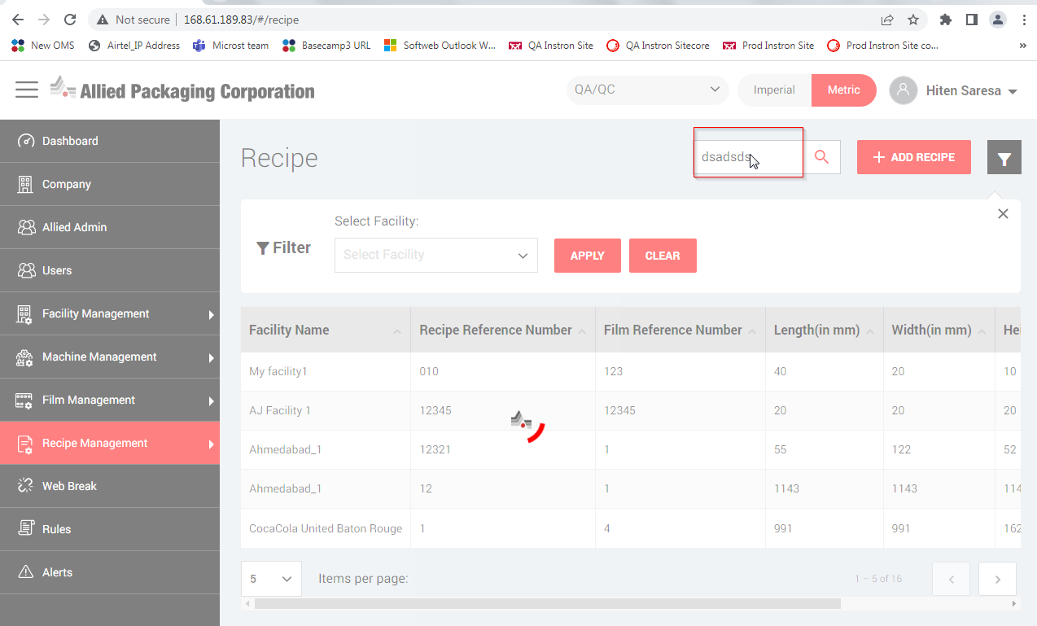

User’s menu not seeing as clickable at top right corner

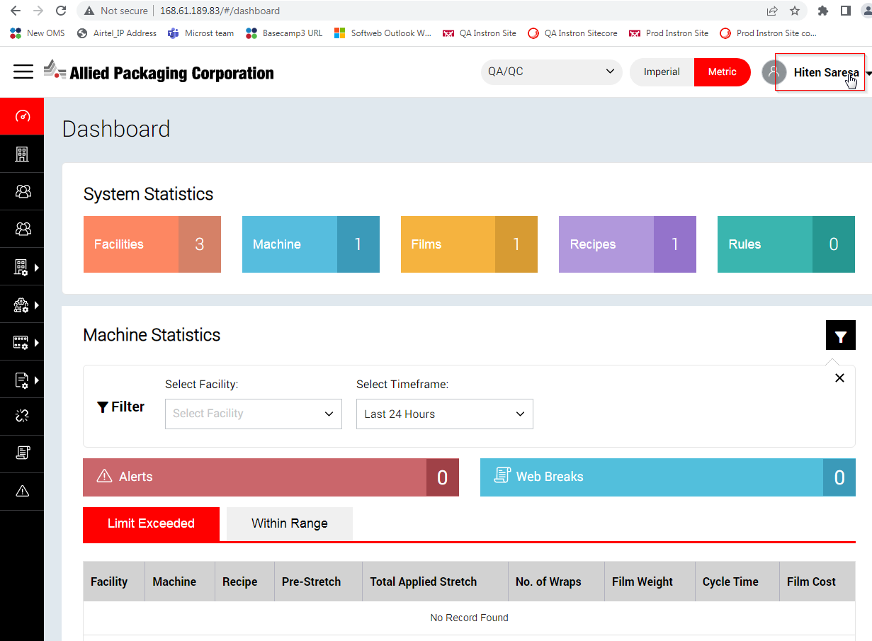

Steps:

1. Login into application
2. Goto > Machine Management > Machine
3. Click on “View Dashboard” icon from Machine page
4. Click on “Back” button
5. Verify is it clickable or not

From RealTime Data page , sometime "Back" button not clickable

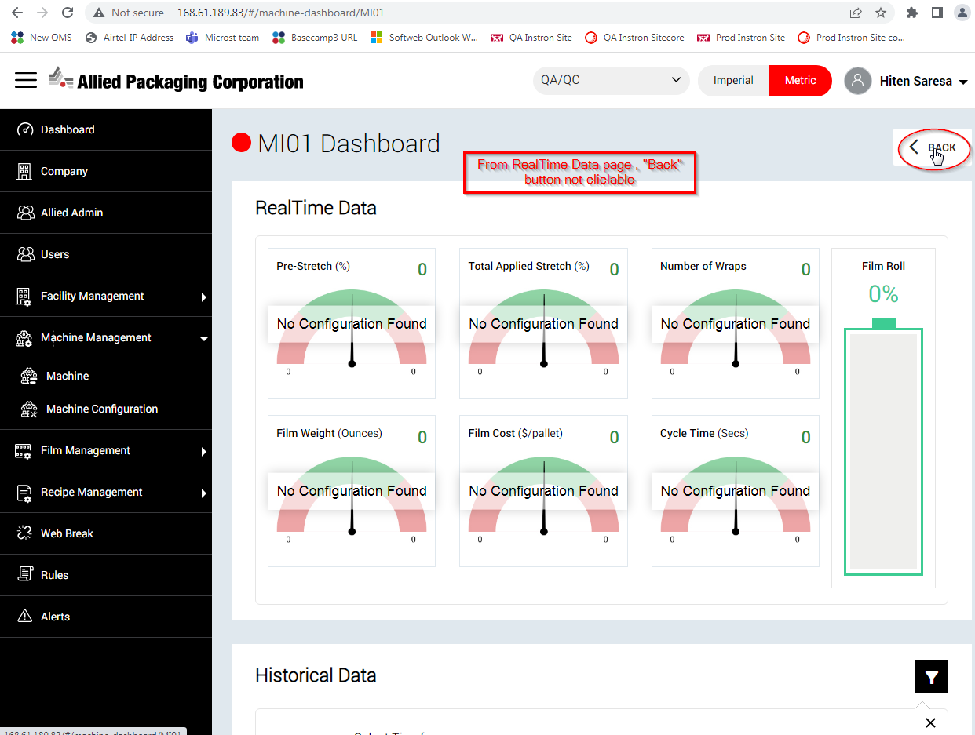

After sorting from header, existing record is getting hide

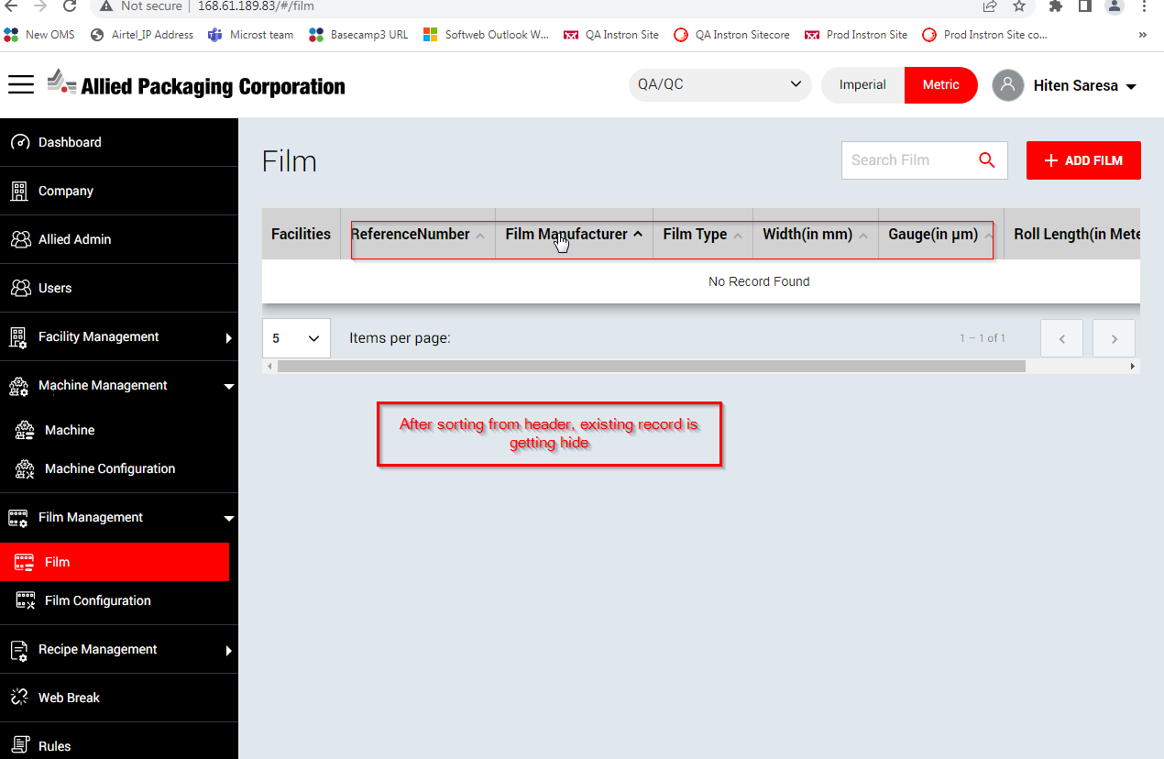

On both Dashboard and Recipe page, Recipes counts are displaying wrong and Recipe record do not change based on Facility filter.

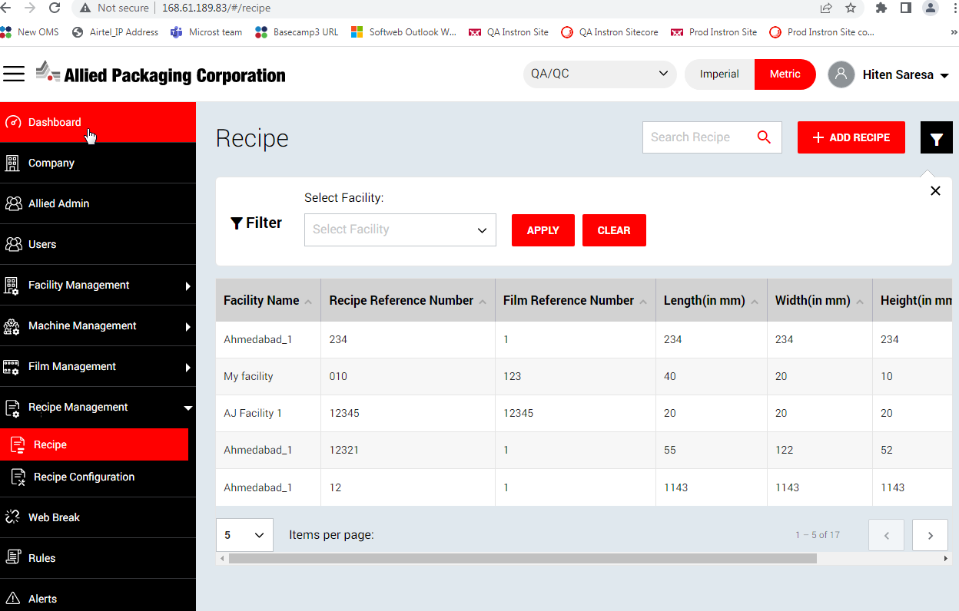

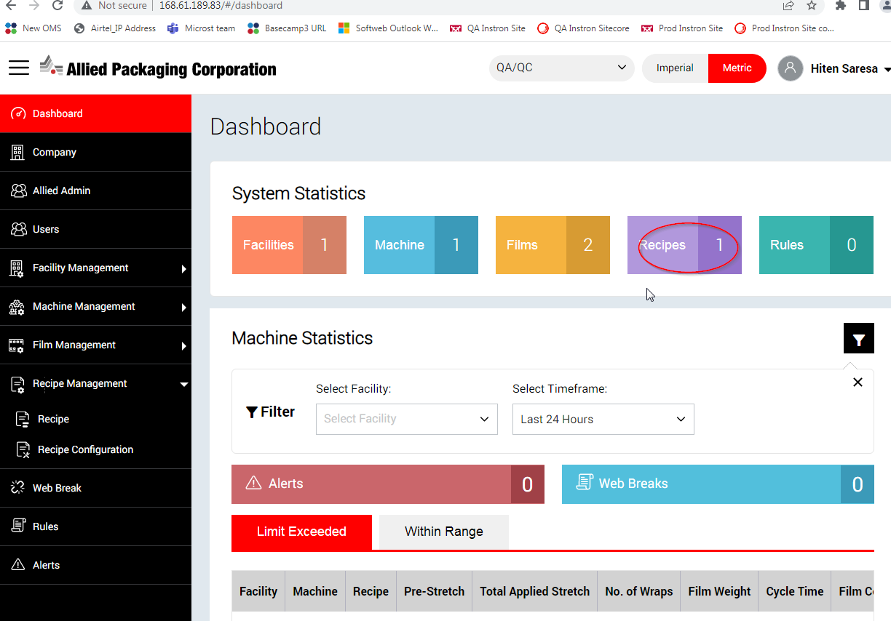

**Suggestion:** Alert should be displayed with red color when user select any tab like Rules and no records are available.

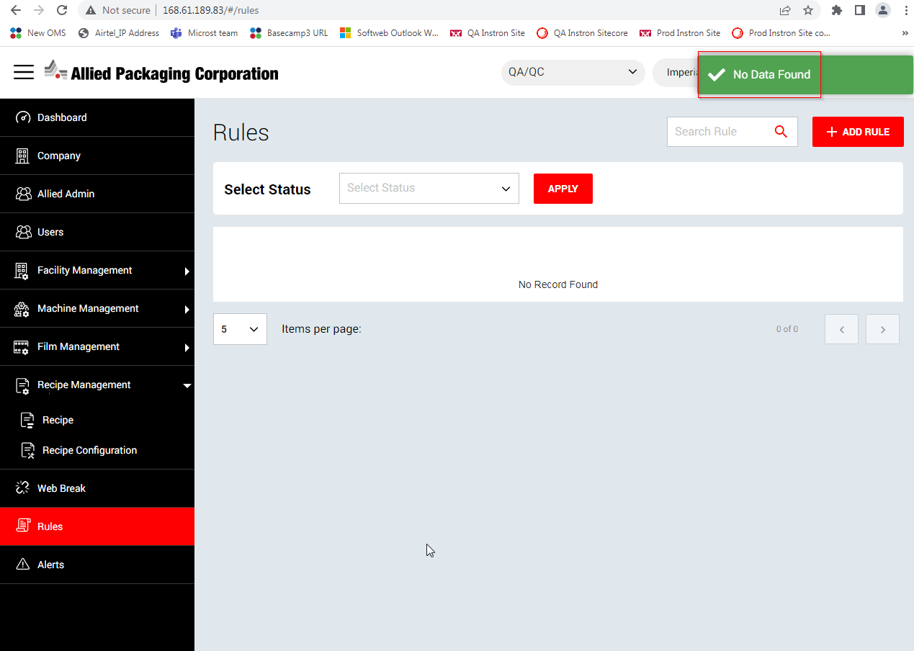

Validation error displaying touched with fields in across application.

**Expected**: Space should be provided when validation error comes in across application

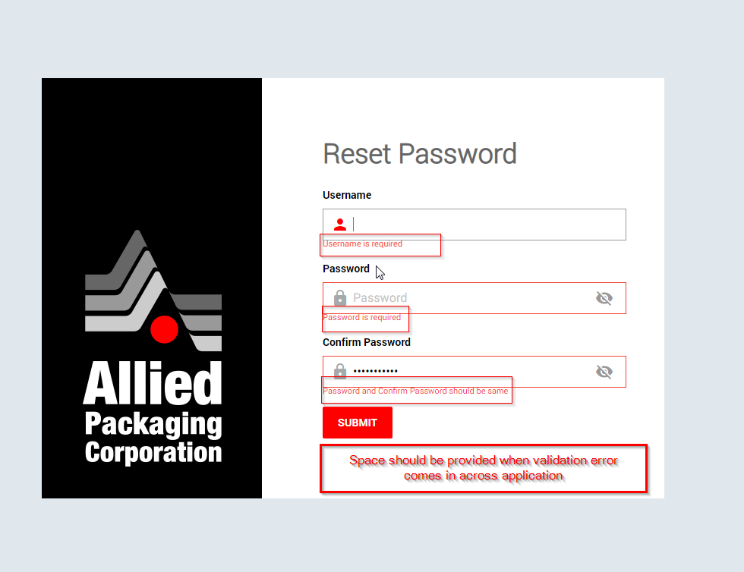

After updating My profile details , Spelling of “Successfully” seems incorrect when message comes. It should be successfully instead of successsfully.

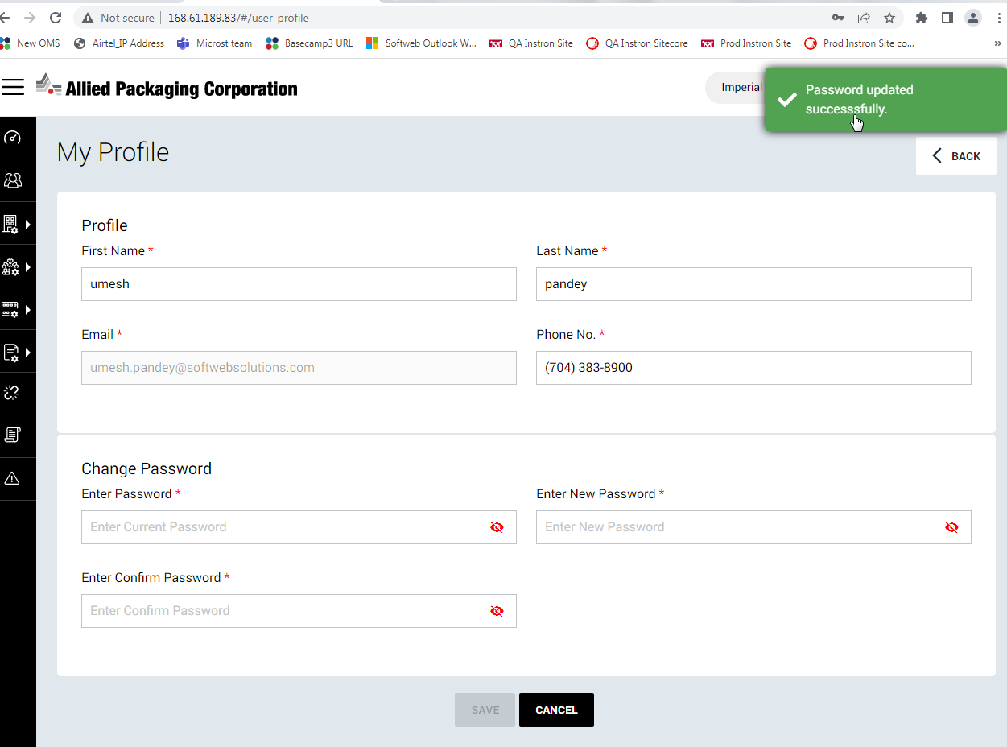

after clicking "View" icon, View Facility page opening with loader

**Steps**:

Goto > Application and login with credentials: “umesh.pandey@softwebsolutions.com/Hello@#1234”

Goto > Facility from left navigation and click on “View” icon

Observe the loader

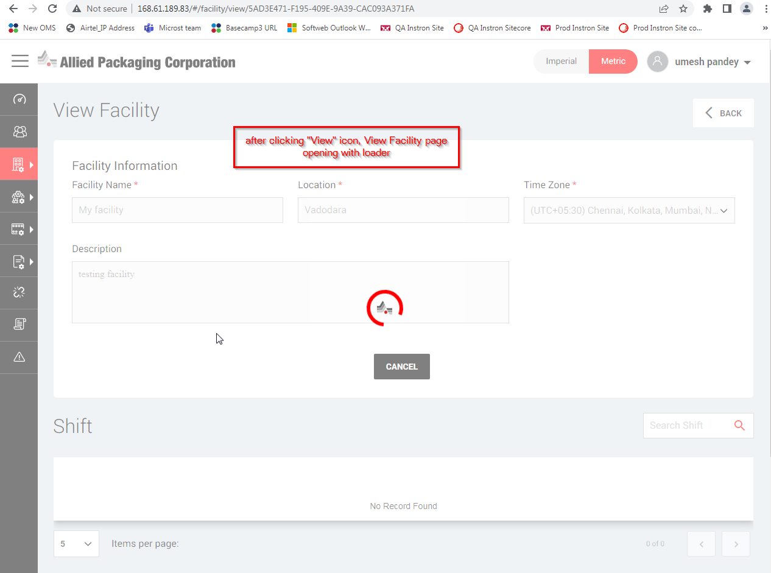

Facility Off Time > “View/Add/Update” icon missing under Actions

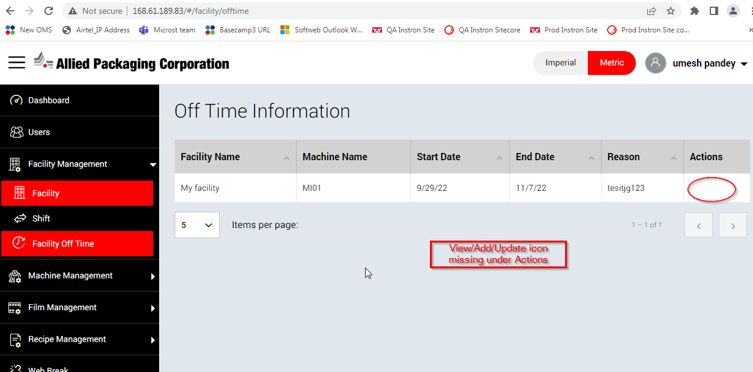

Gauge field value do not revert back while user change from Imperial to Metric

1. Login into application and Goto > Film page and open it
2. Select Imperial tab then Metric tab
3. Observe the “Gauge” field value that revert back or not

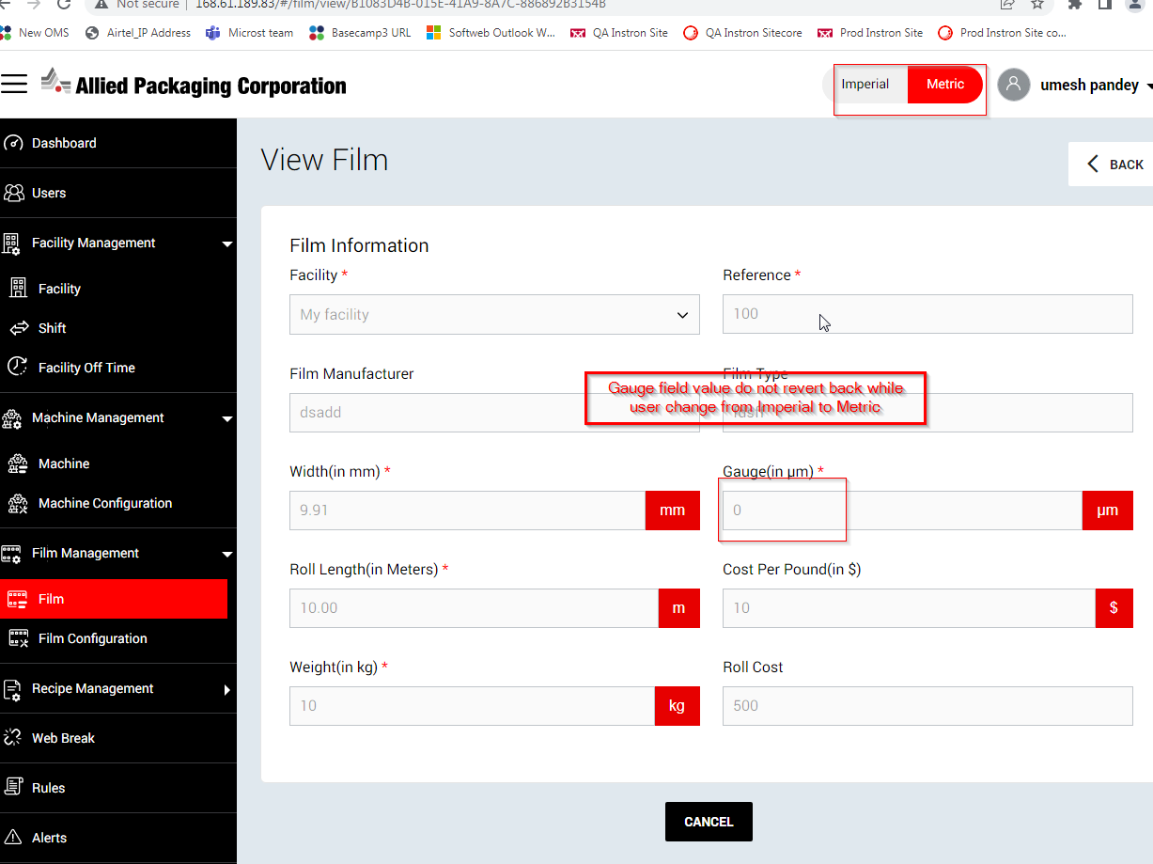

After selecting “Shift” and “Recipe” page from left, Loader displaying

1. Login into application and Goto > Facility > Shift and Recipe from left
2. Observe page being loaded or not

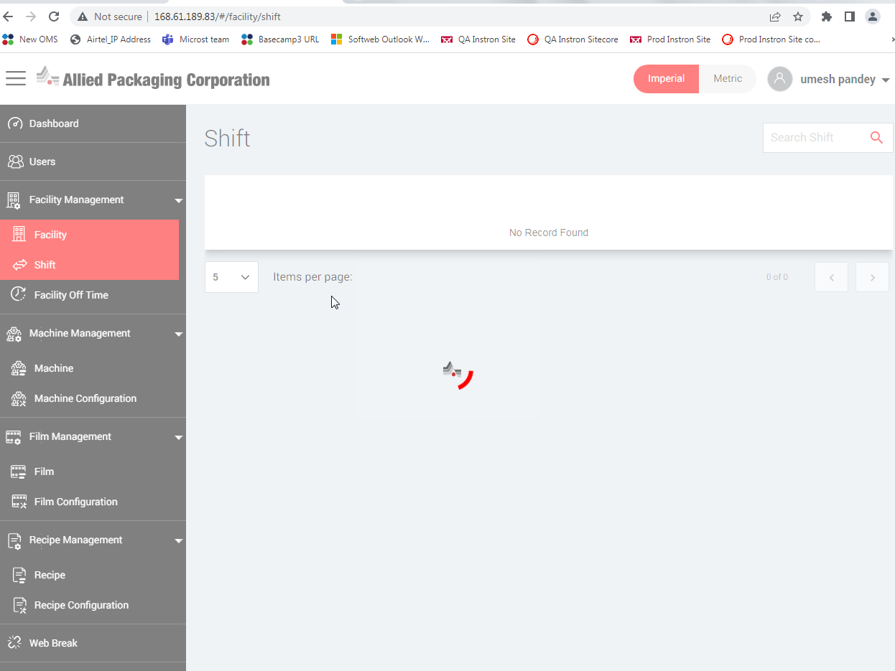

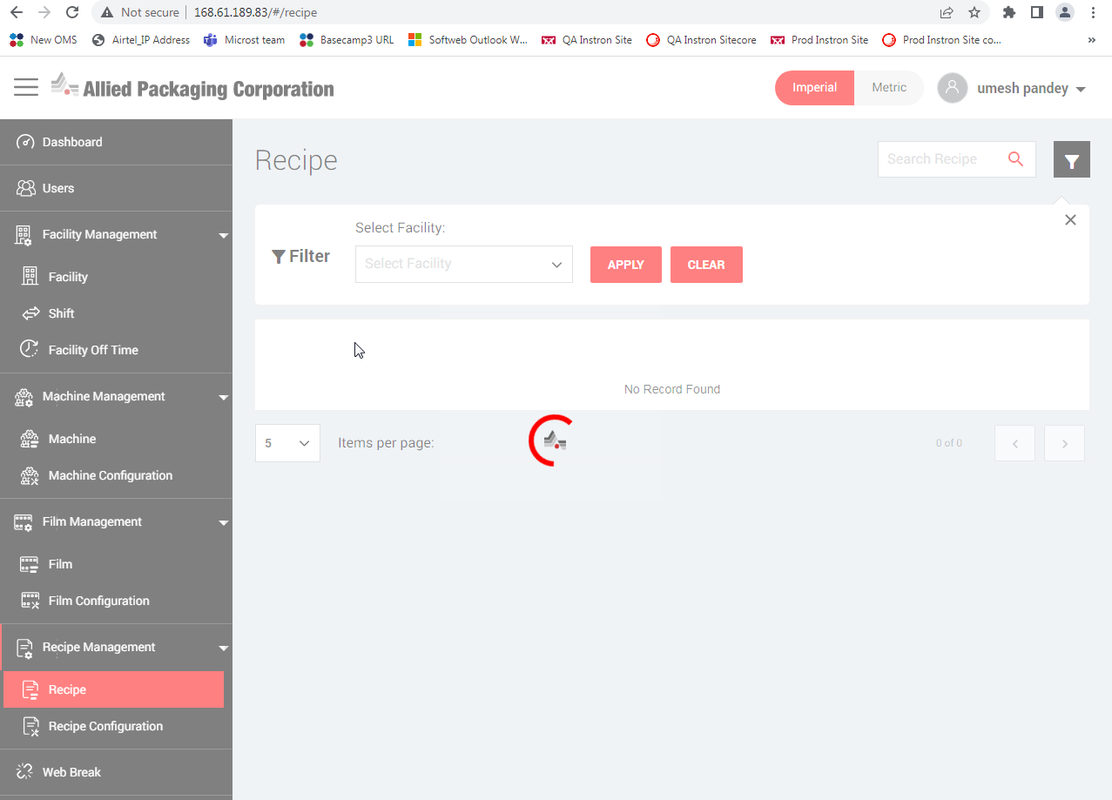

As per applied user permission, "Edit/Delete" button should be displayed in Off time information but currently it is displaying Delete button only

Steps:

1. Login with Super admin / Allied admin credentials into application and select “QA/QC” company from drop down
2. goto > Users module and ticket “Manage” check box for Facility Off time and Save it
3. Login with user’s credentials: [“umesh.pandey@softwebsolutions.com/Hello@#1234”](mailto:\“umesh.pandey@softwebsolutions.com/Hello@#1234\”)
4. Goto > Facility Management > Facility Off Time and check the button (Edit/Delete) under Actions

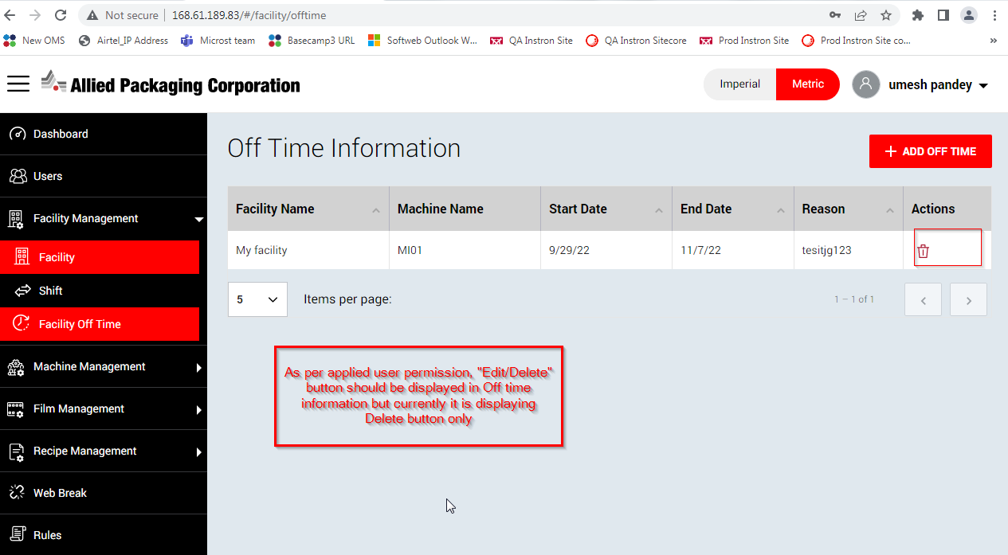

From Users > Send Notification page, It should be +1- instead of 1-

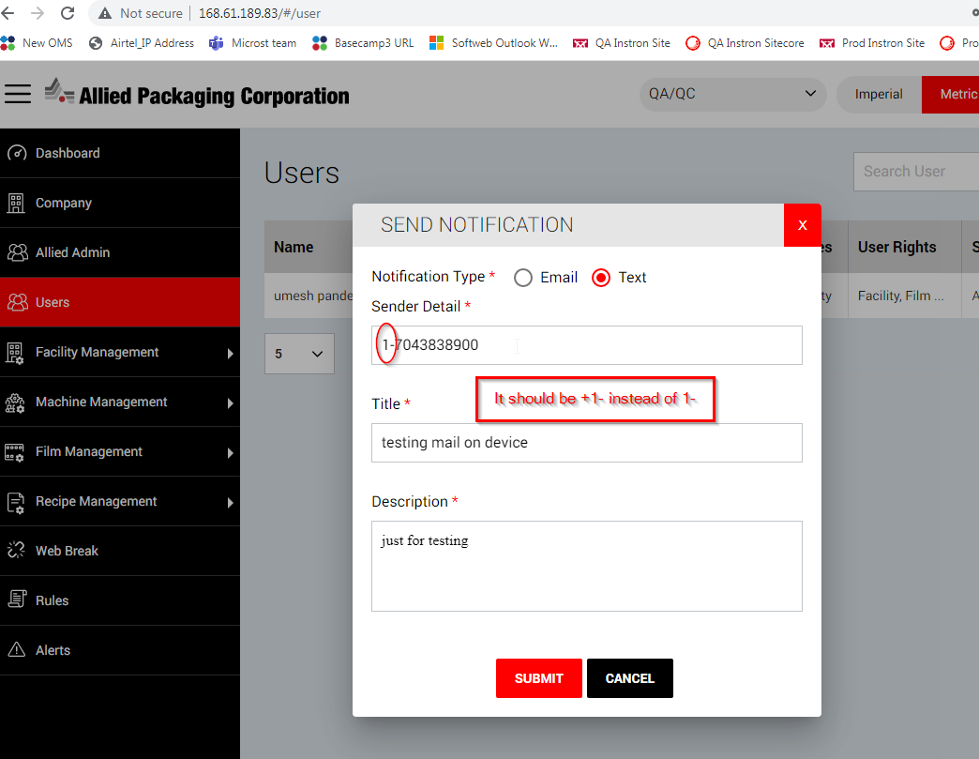

In Rules page > No. Of user’s count displaying wrong.

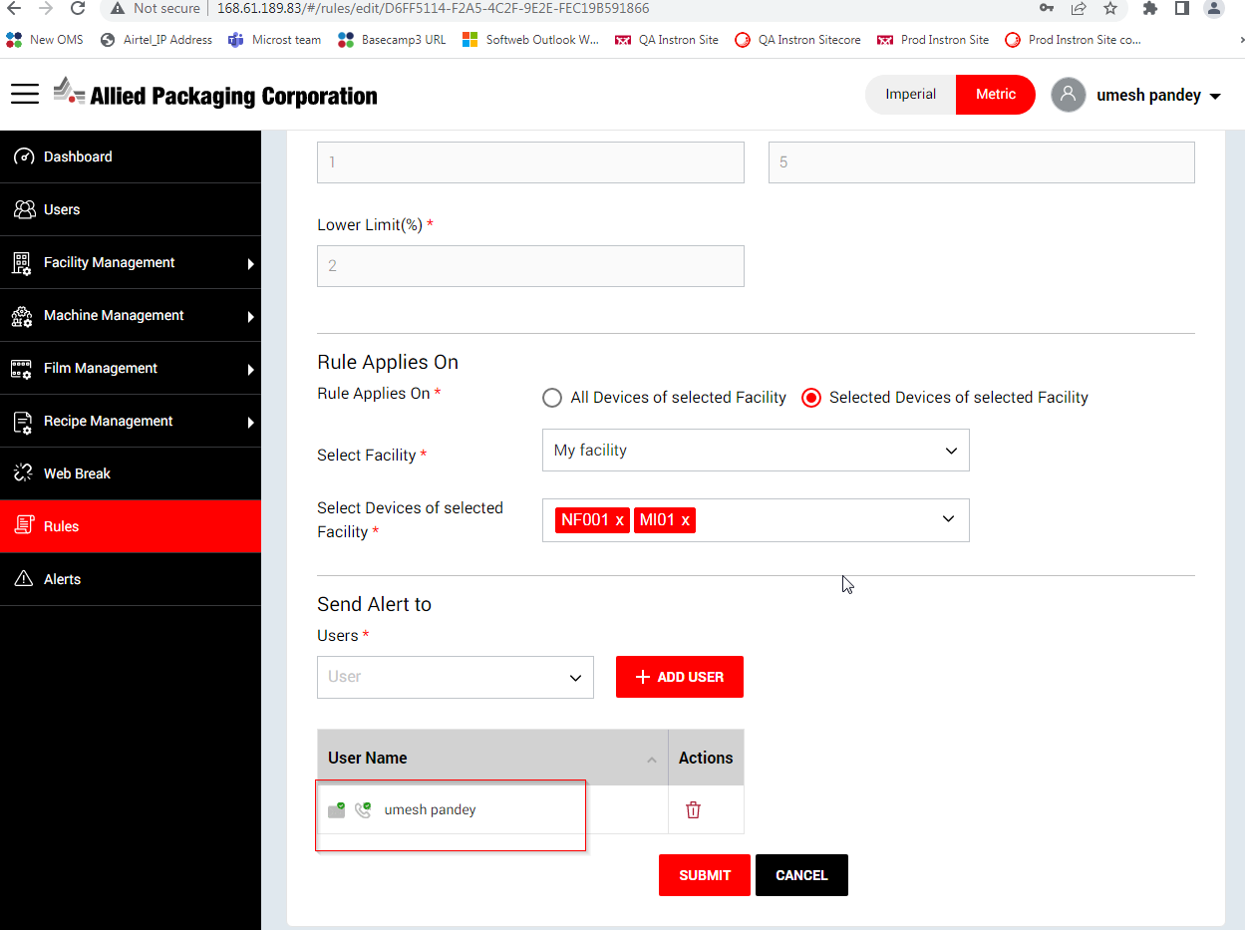

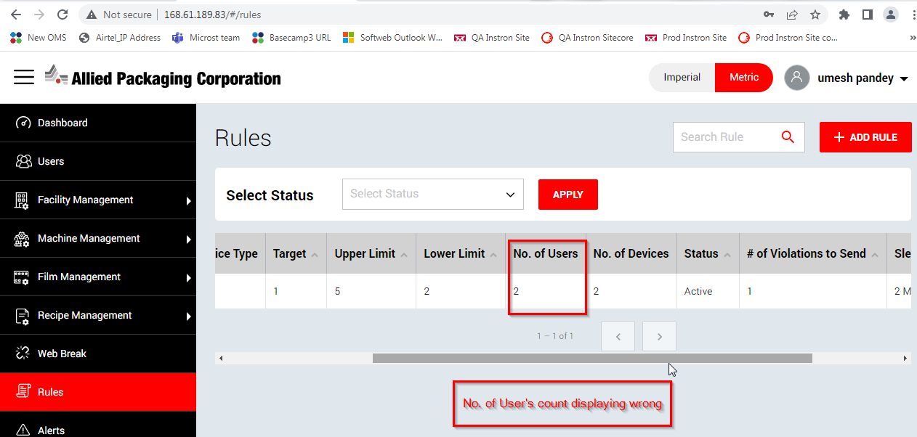

**Suggestion**: Account Activation > Reset Password, Should be thrown below alert when user click “Click Here” link after long time instead of entering Reset Password details.

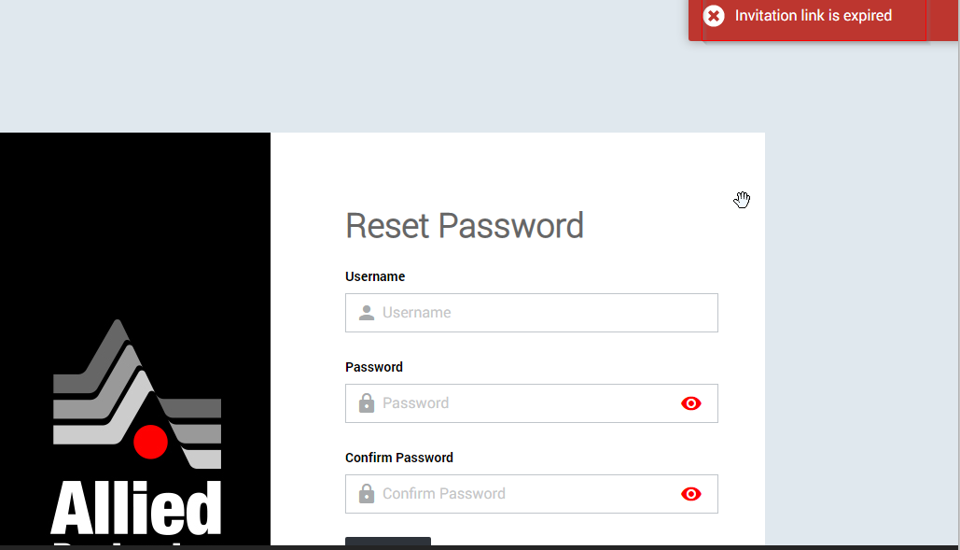

From Alerts module > Alert Info > Range Data popup, “Copy to clip” icon is not working

**Steps**:

1.Goto > Alerts module

2.select company name from drop down

3. click “I” icon from Alerts page

4. Click on “View Details” from Range Data

5. Click on “copy to clip” icon from top left corner

6. Observe its clickable or not

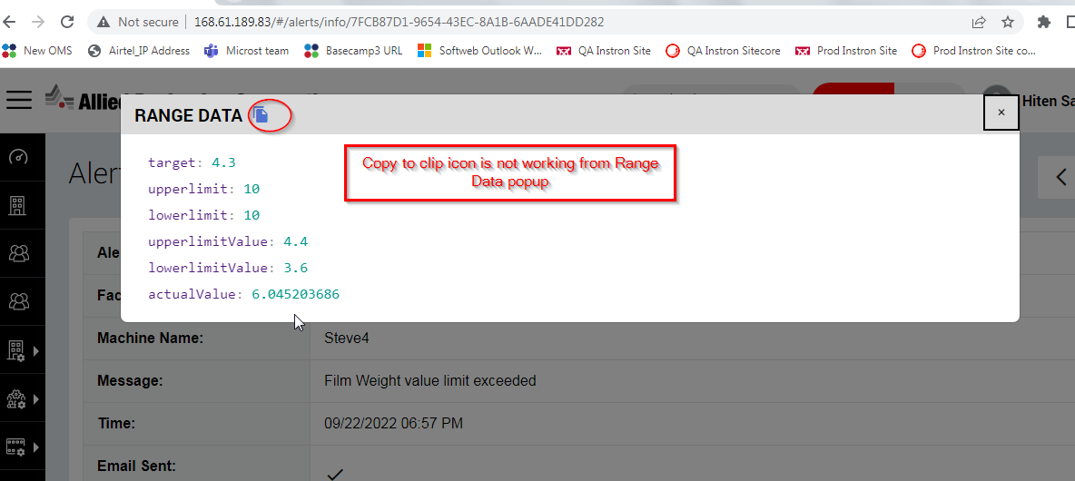

From Alerts module > Alert Info > Range Data popup, lowerlimit and lowerlimit value displaying incorrect

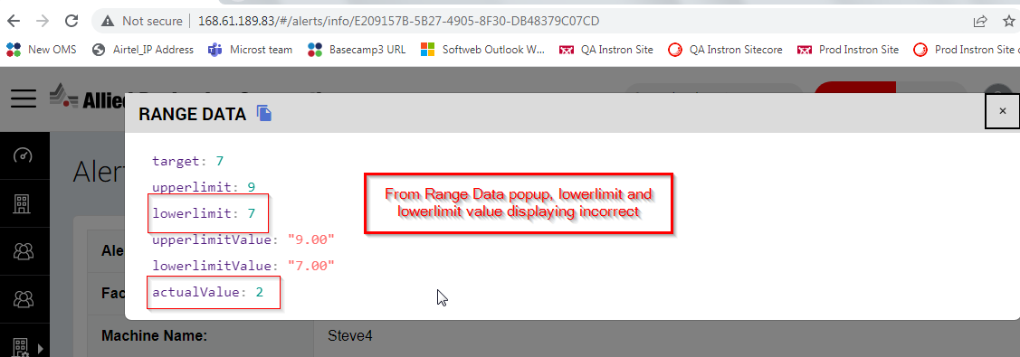

From Alerts module > Alert Info > Event Data, Copy to clip icon not clickable and lower_limit value displaying incorrect.

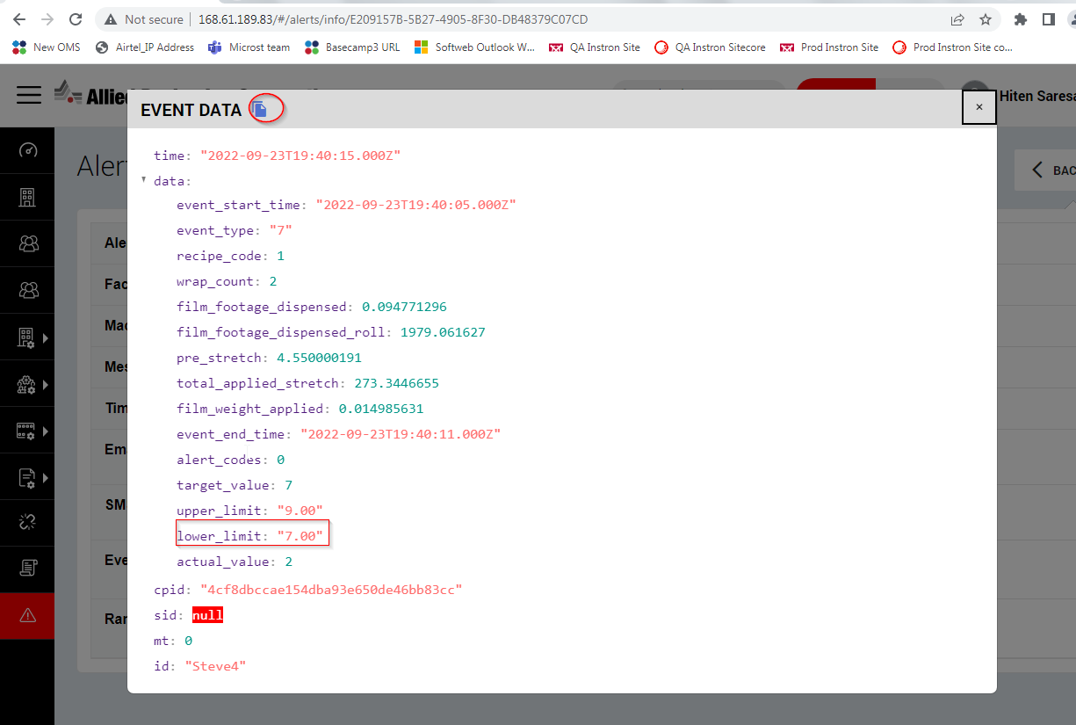

Alerts module , Throwing below alert on screen when user click on header icon to sorting the records or click on any button

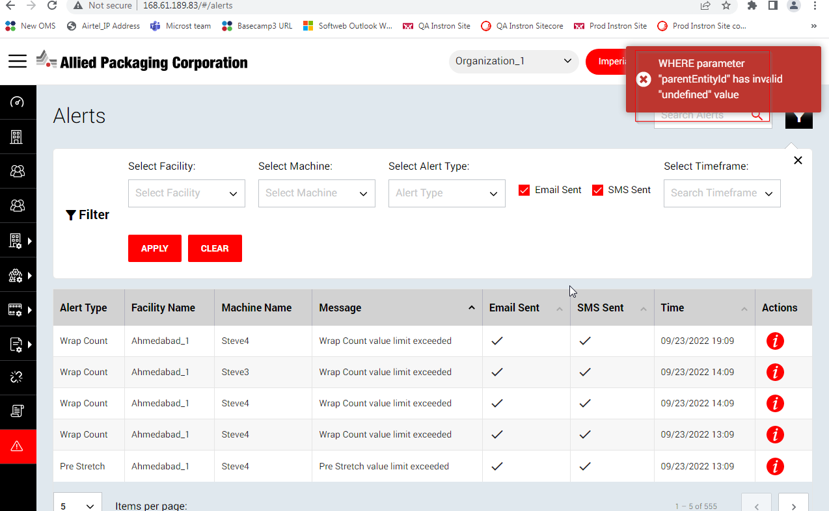

From Alerts page, Unwanted loader displaying when user filter with any Alert Type like Roll Change and click on Info icon

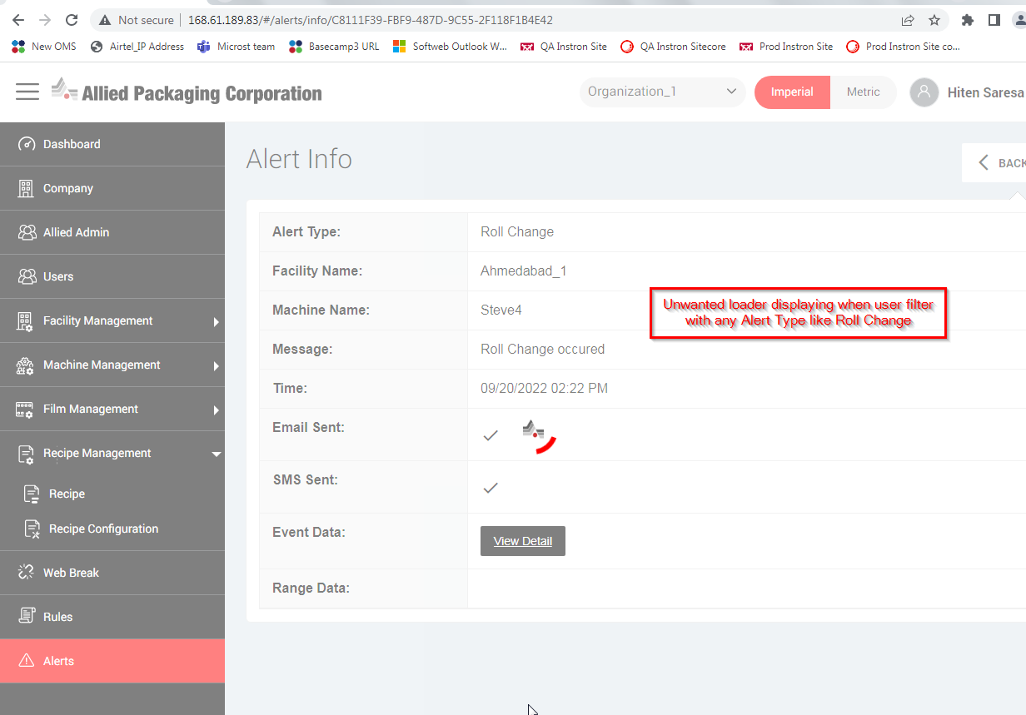

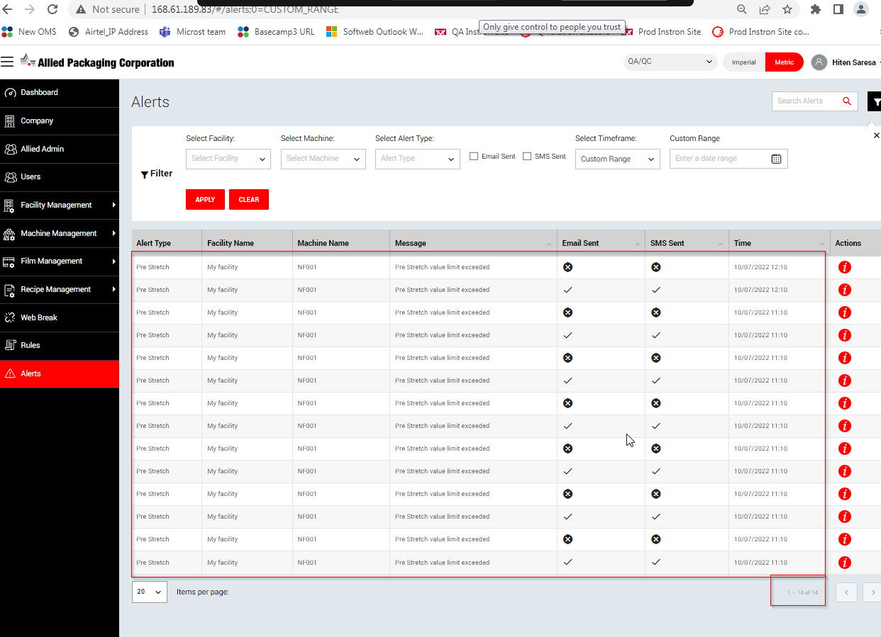

**Date- 13th Oct 2022**

Alert counts are seeing miss matched when filter from Dashboard > Alerts and goto Alerts page and verify the counts.

**Steps**:

1. Login into application and goto > Dashboard > Alerts
2. Filter for alerts and select time frame as Last 7 days
3. Click on Alerts count and verify both counts

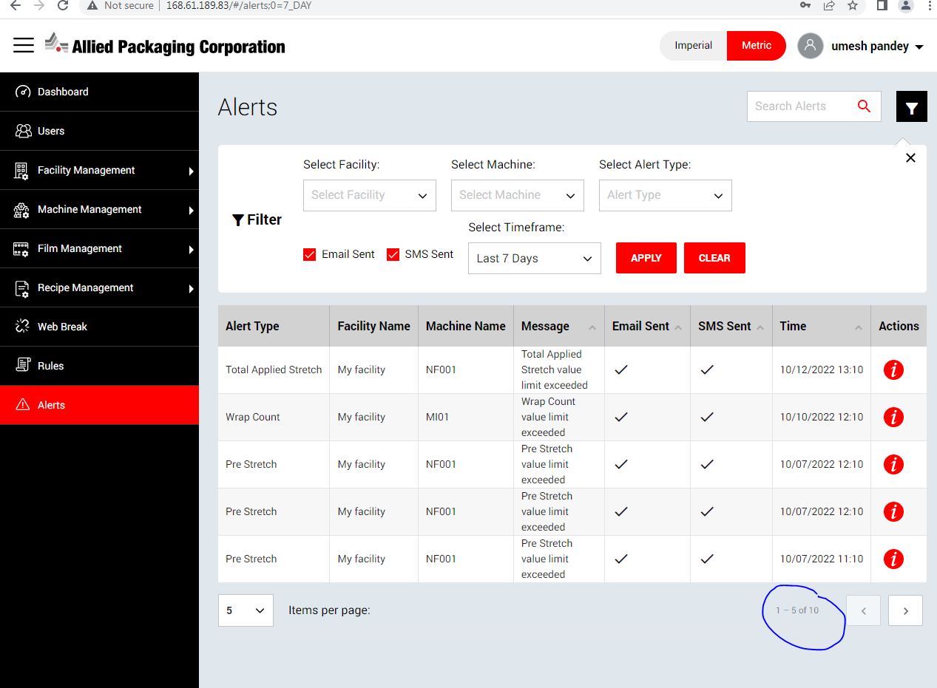

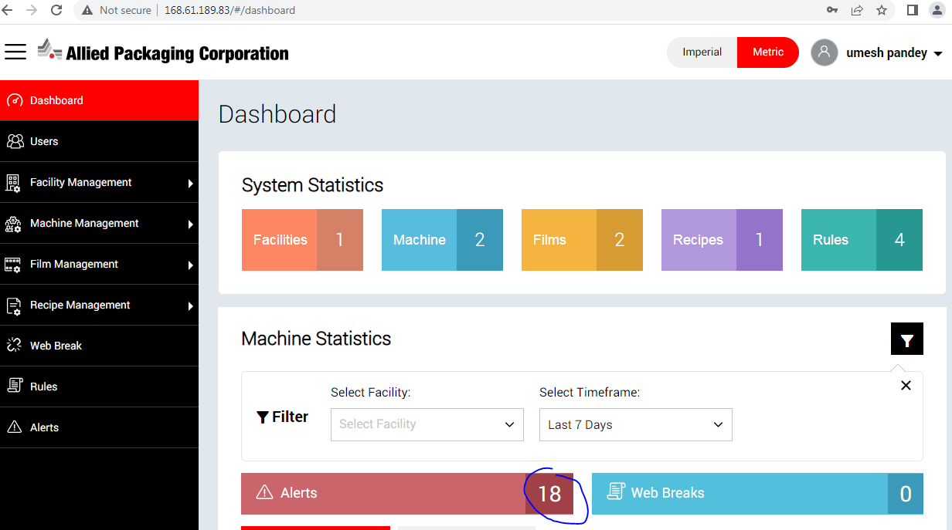

“+Add Super Admin” button running out of border line when user expand the left navigation

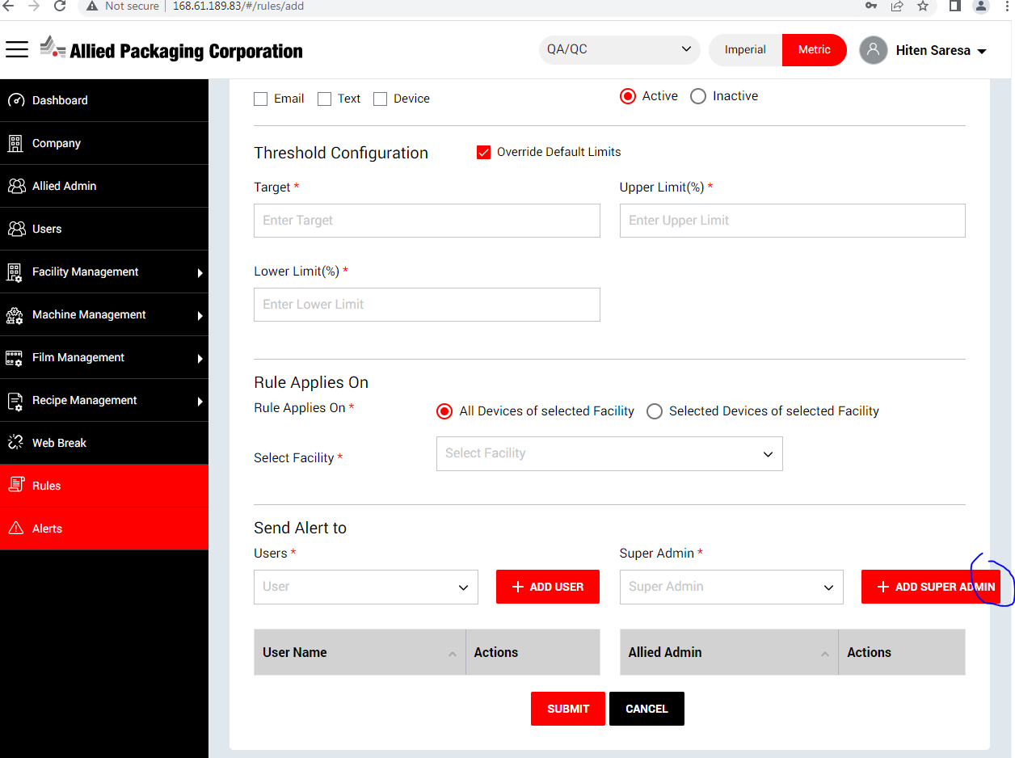

Selected Alerts Filter criteria and Alerts count do not matched inside the Alerts page when select it from Dashboard page

**Steps**:

1. Login into application and goto > Dashboard > Alerts
2. Filter for Alerts and Alerts record will be found.
3. Click on Alerts count and page will be redirected
4. verify the Alert filter and Alerts count on Alerts page are being displayed properly or not

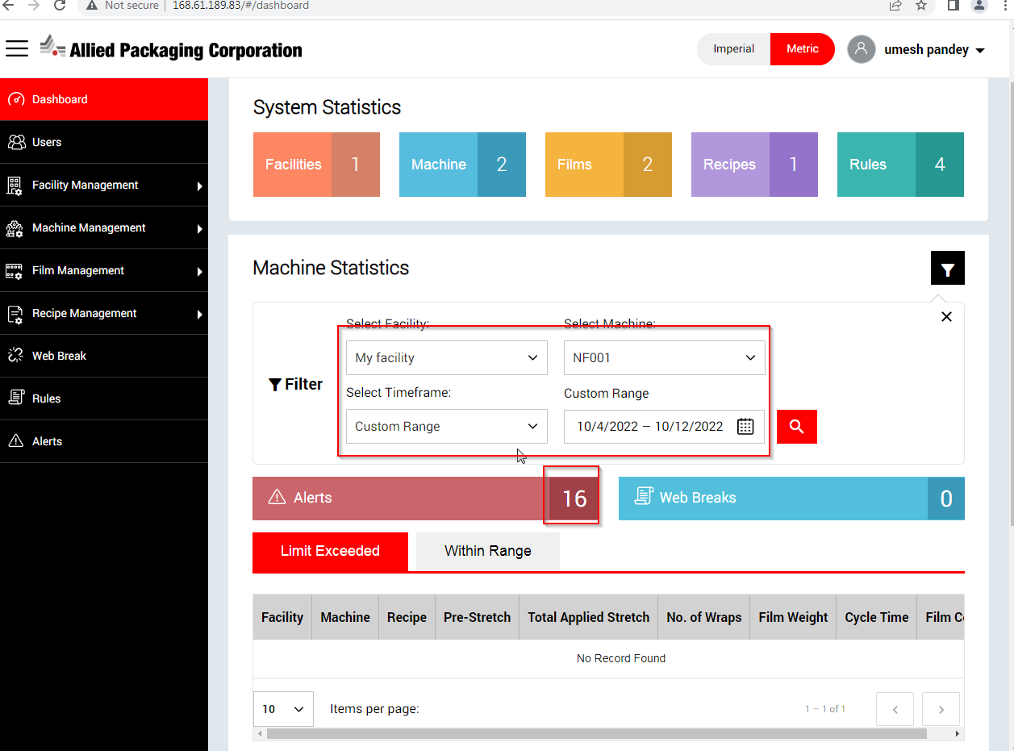

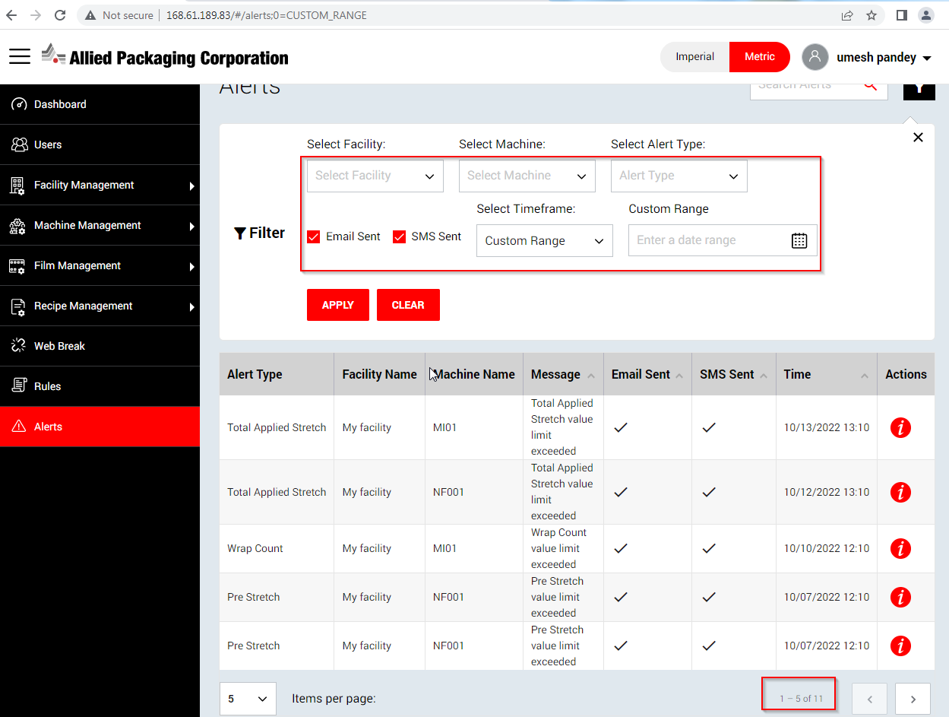

**Date- 27th Dec 2022**

Facility Off Time > Entered Start Time / End time displaying wrong on Edit Off Time screen.

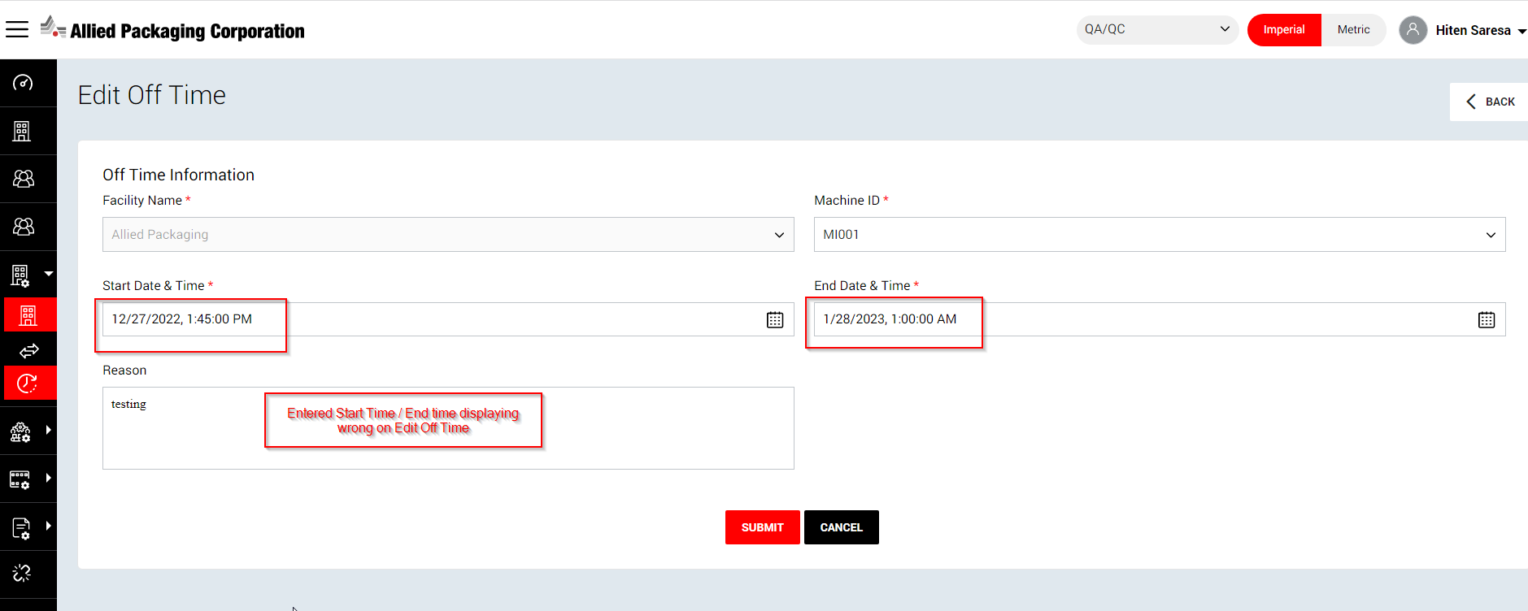

Facility Off Time > Start Date / End Date should be displayed with Time also and Date format should be uniformity in across pages in application

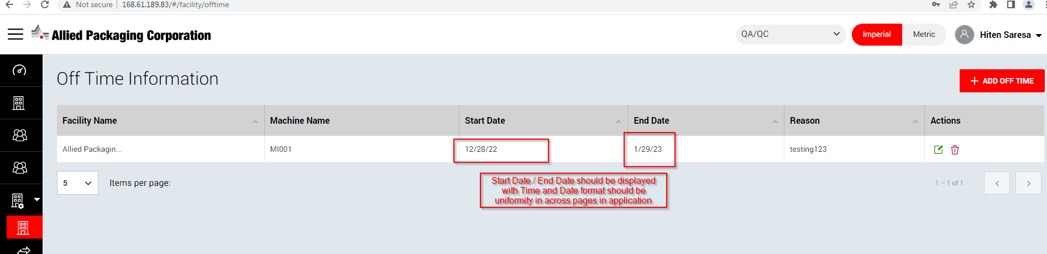

Machine > Machine Real Time Data page getting stucked after clicking “View Dashboard” icon from the Machine page.

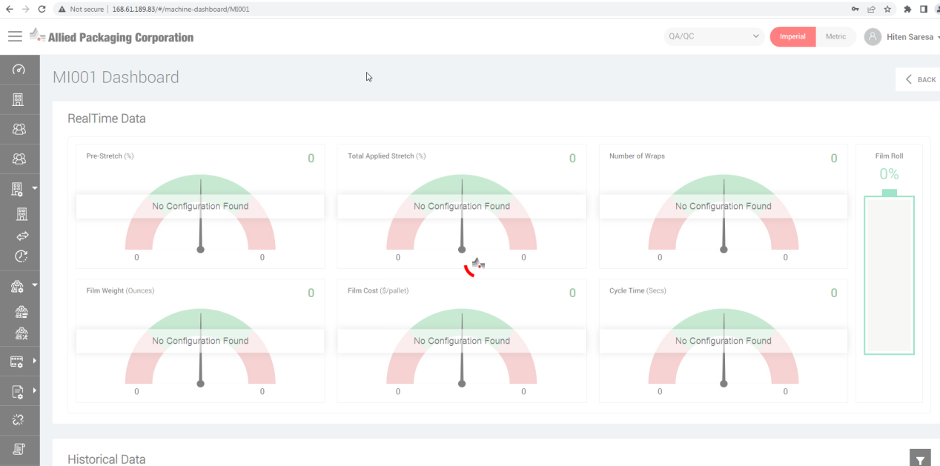

When user stay on Machine Real Time Data page of QA/QC afterward switch to Organization_01 and click Back button , below 404 page error occurs

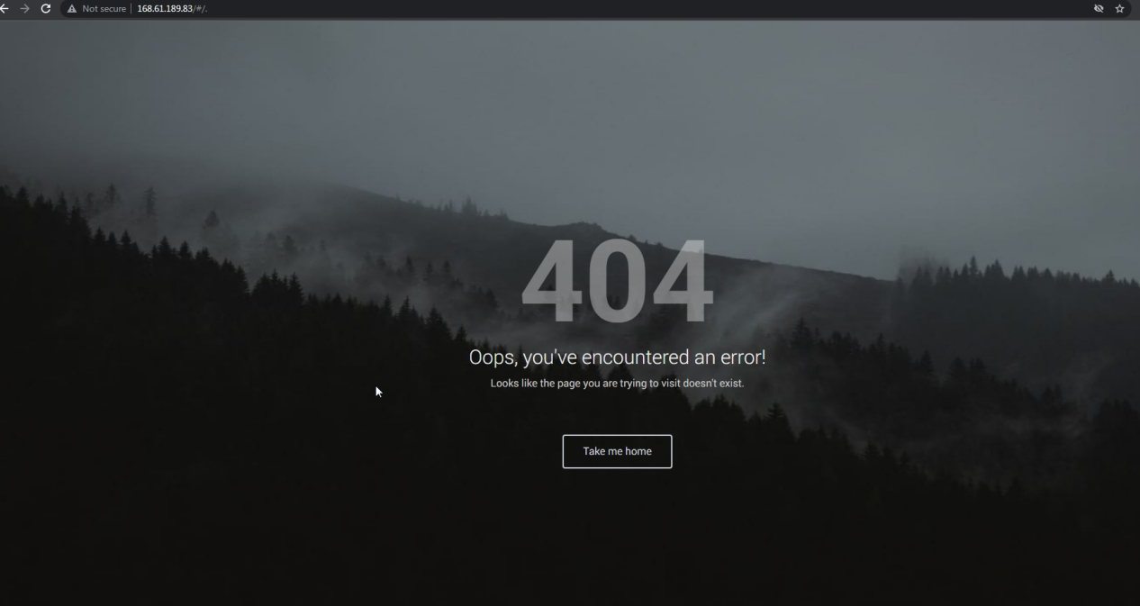

Machine RealTime Data do not display properly when user setup data from IOT connect portal and back to Machine Real Time data screen

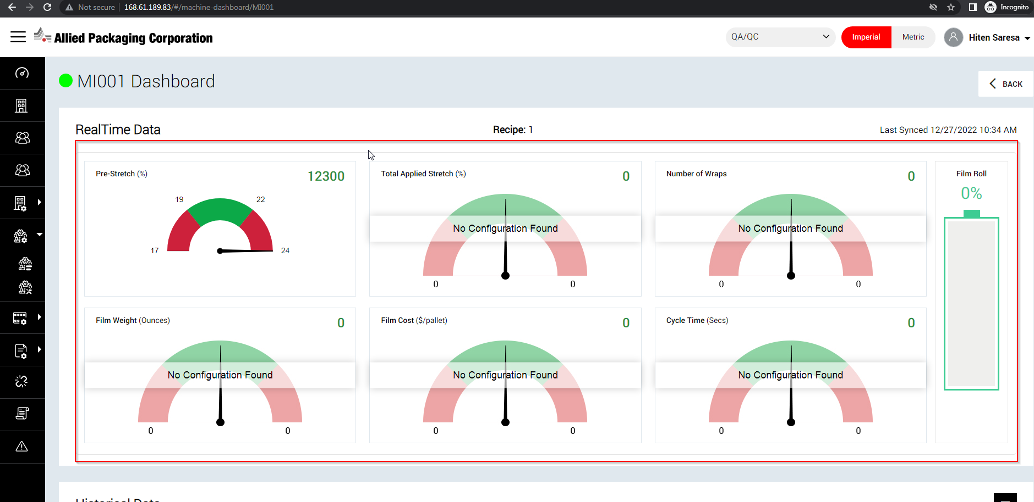

Historical Graph data do not load when user setup data from IOT connect portal and back to Machine Real Time data screen > Historical Data section

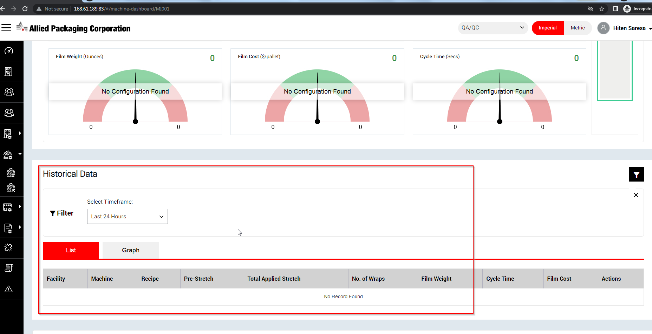

“Back” button not clickable from Machine Real Data Time screen when user stay on same page till 2-3 mnts afterward click on Back button

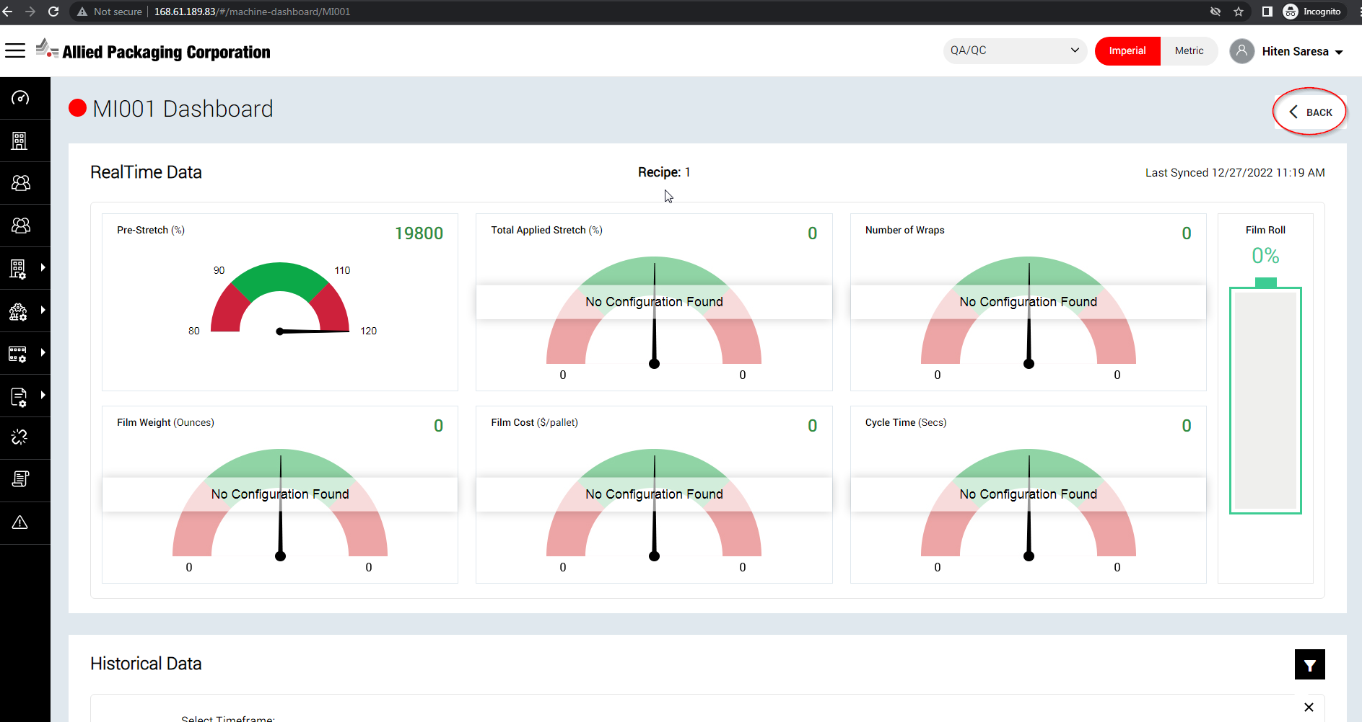

**Date- 28th Dec 2022**

When user goto > Facility page and click “I” icon , does not happen anything

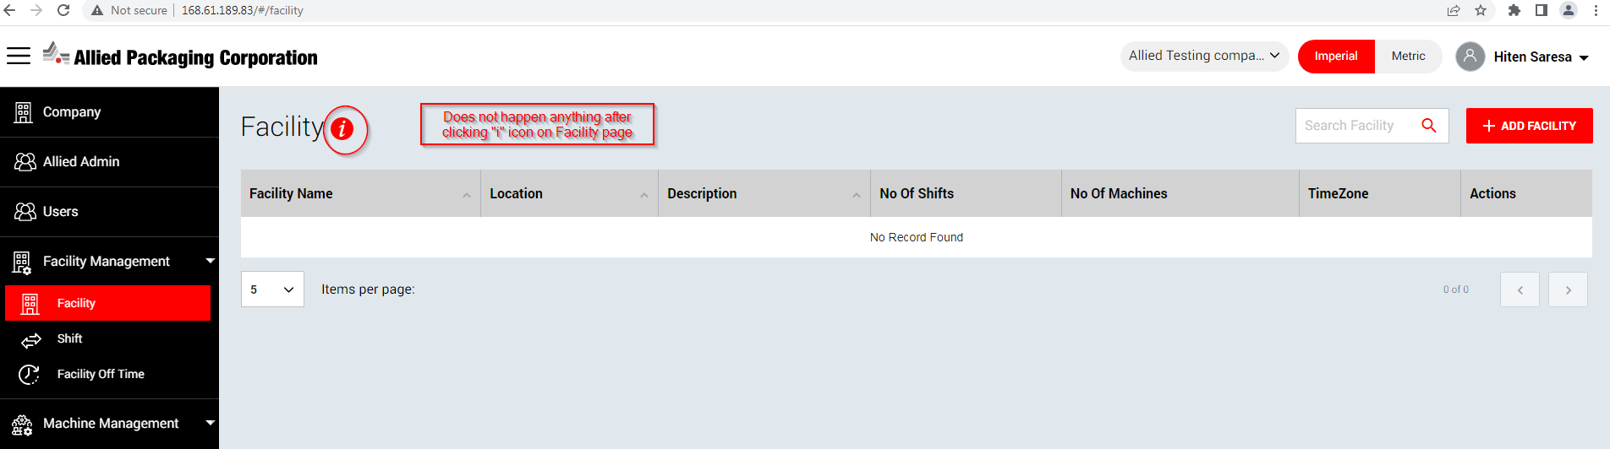

On Edit Film page , Width , Roll Length and Weight value getting changed when user switching Imperial tab to Metric tab

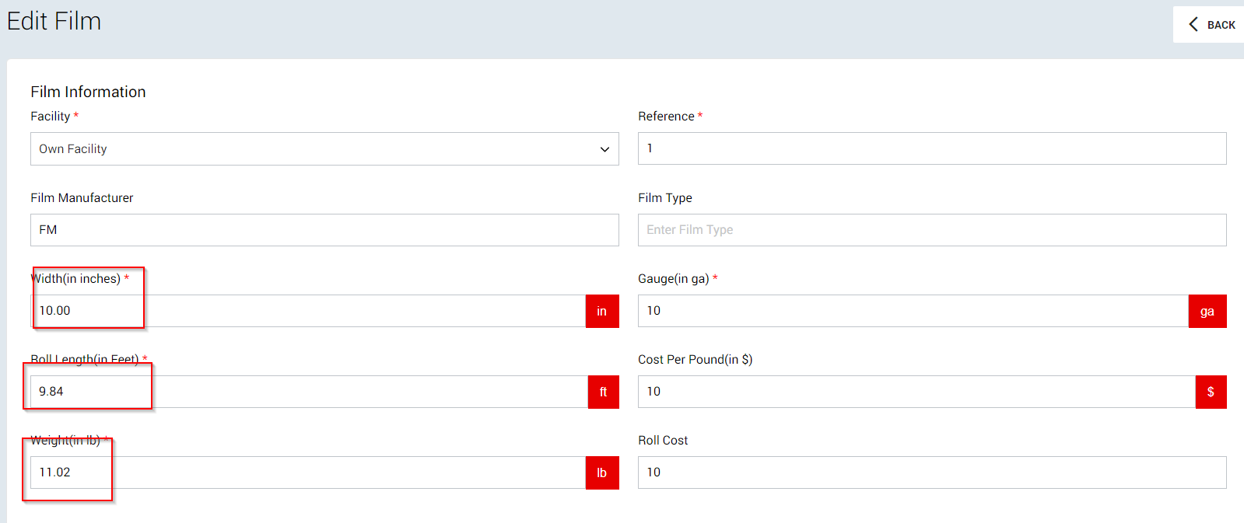

On Edit Recipe page, Length , Width and Height value getting changed when user switching Imperial tab to Metric tab

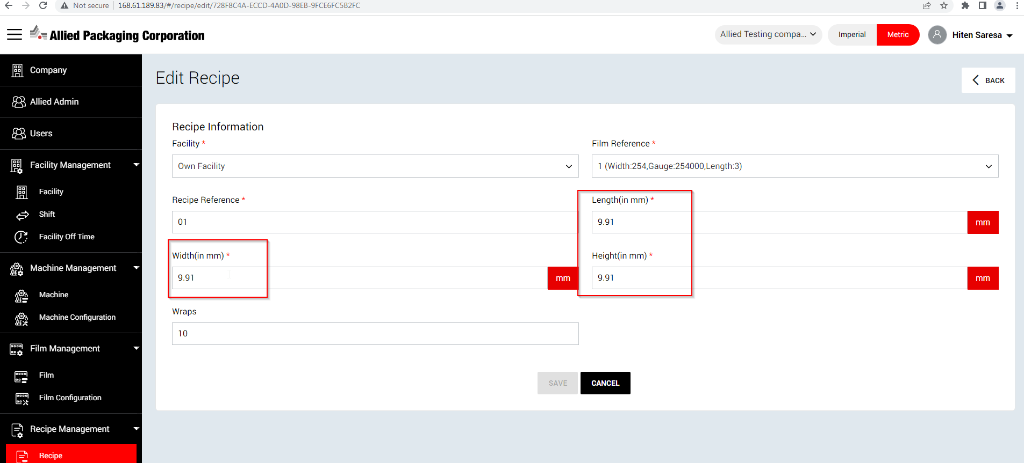

**Date- 11th Jan 2023**